Healthcare Financial Management Association

**Certification Program**

**Module I: HFMA Business of Health Care**

**Learner’s Guide**

**Course 1 - The Big Picture**

Learning Objectives

* Describe the general characteristics of the healthcare industry in the US;
* Describe the impact of health reform on the industry;
* Describe the payment system for healthcare services;
* Define the role of financial management in health care organizations; and
* Describe some of the new challenges facing healthcare finance in the US.

1. The following diagram presents an overview of the US Healthcare System. Be prepared to identify and explain the transactions that occur for each specific entity in the diagram.

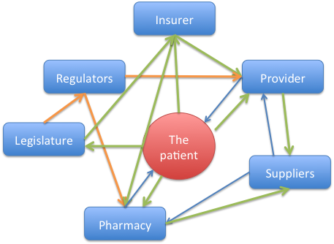

1. Who has direct transactions with the patient? What is the nature of the(se) transaction(s)?
2. Who has direct transactions with the provider? What is the nature of the(se) transaction(s)?
3. Who has direct transactions with the insurer What is the nature of the(se) transaction(s)?

2. Fill in the blank with the correct work t o complete the sentence

1. A party rendering medical care such as a physician or hospital is called a __________
2. _____________ includes hospitals, skilled nursing facilities, assisted living facilities, home health agencies, and ambulatory surgery centers
3. Physicians serving in ______________roles usually treat common medical conditions or injuries, and often provide preventive health screenings

3. Define each of the following patient payment portions

|  |  |
| --- | --- |
| **Patient Payment Type** | **Definition** |
| Out-of- pocket payment |  |
| Deductible |  |
| Coinsurance |  |

4. The following diagram illustrates the flow of money and services with employer provided insurance. Be prepared to explain the various transactions.

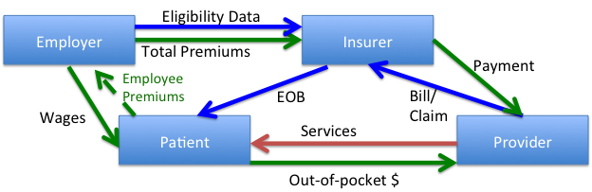

1. What does the employer prove to the insurer?
2. The green line in the diagram is the flow of money. Explain the patient’s financial transactions in the diagram
3. The glue line represents data exchange among various entities. Explain each of the data transactions- what data is provided to what entity for what purpose?

5. Understanding Medicare – fill in the chart below

|  |  |  |
| --- | --- | --- |
| **Medicare Program** | **Services** | **Eligibility** |
| Part A |  |  |
| Part B |  |  |
| Part D |  |  |

6. The diagram below presents an overview of the flow of money and services for a patient with Medicare Parts A & B coverage. Be prepared to explain the transactions between the entities.

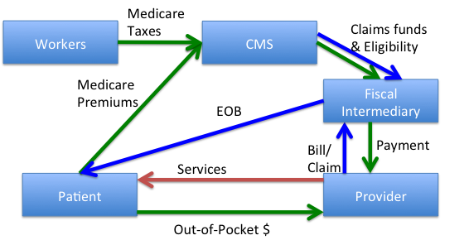

1. Describe the role of the fiscal intermediary in terms of the transactions represented in the diagram.
2. Explain how workforce Medicare taxes are transferred to a provider?
3. Explain how a “claim” works as presented in the diagram
4. Describe the role of CMS s in terms of the transactions presented in the diagram

7. The diagram below presents the flow of money and services for a patient with Medicaid coverage. Be prepared to explain all of the transactions represented in the diagram.

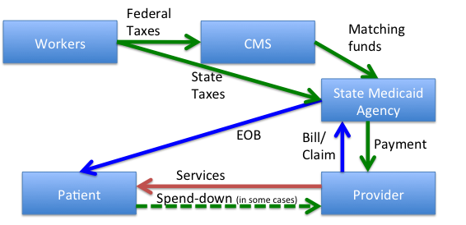

1. Describe how federal tax dollars are transferred to a provider?
2. Explain the role of the state Medicaid agency in terms of the transactions presented in the diagram.
3. Describe how state tax dollars are transferred to a provider?

8. Understanding major reform initiatives – complete the chart below:

|  |  |  |
| --- | --- | --- |
| **Reform Initiatives** | **Definition** | **Significance of this Initiative?** |
| The Employer Mandate |  |  |
| Insurance Exchange |  |  |
| Accountable Care Organization (ACO) |  |  |
| Bundled payments |  |  |

**Notes:**

**Course 2 - Financial Accounting Principles**

Learning Objectives

* Describe the basic elements of accounting;
* Differentiate between the key financial statements and what they describe;
* Conduct a basic analysis of an organization’s financial condition using financial statements;
* Relate basic measures of operational performance to an organization’s financial statements; and
* Know what other accounting reports are usable in the analysis of financial statements.

**Accounting Basics**

Double Entry:

|  |  |
| --- | --- |
| **Term** | **Definition** |
| Asset |  |
| Likability |  |
| Net Income or Equity |  |

The” Matching Principle”:

“Accrual”:

Accrual basis of accounting:

“GAAP”:

Cash=Basis of Accounting:

**Key Financial statements**

Income statement:

**Sample Income Statements for physicians, hospitals and health insurers**

|  |  |  |  |
| --- | --- | --- | --- |
| **Item** | **Physician Clinic** | **Hospital** | **Health Plan** |
| **Revenues** | Gross revenues | Gross Revenues |  |
|  |  | Premium Revenues |
| - deductions and allowances | - deductions and allowances |  |
| - bad debt | - bad debt |  |
| - charity care | - charity care |  |
| Net patient revenue | Net patient revenue |  |
| Other operating revenue | Other operating revenue | Other operating revenue |
| **Total Revenue** | **Total Revenue** | **Total Revenue** |
| **Expenses** |  | | Medical Claims Expenses  - fee-for-service claims  - capitation  - carve-outs and subcontracts  - reinsurance |
| **Underwriting Profit** |
| Administrative expenses |
| Salaries & Benefits | Salaries & Benefits |  |
| Supplies | Supplies | Salaries & Benefits |
| Purchased services | Purchased services | Purchased services |
| Insurance | Insurance | Insurance |
| Rental Expenses | Rental Expenses | Rental Expenses |
| Depreciation & Amortization | Depreciation & Amortization | Depreciation & Amortization |
| Other Operating Expenses | Other Operating Expenses | Other Operating Expenses |
| **Total Expenses** | **Total Expenses** | **Total Expenses** |
|  | **Operating Income** | **Operating Income** | **Operating Income** |
|  | Other non-operating income/expenses | Other non-operating income/expenses | Other non-operating income/expenses |
|  | **Net Income** | **Net Income** | **Net Income** |

Bad Debt:

Charity care:

**The Balance Sheet**

| **Item** | **Physician Clinic** | **Hospital** | **Health Plan** |
| --- | --- | --- | --- |
| **Assets** | | | |
| **Current Assets** | Cash and short-term investments | Cash and short-term investments | Cash and short-term investments |
| Net patient accounts receivable | Net patient accounts receivable | Premiums receivable |
| Inventory | Inventory |  |
| Prepaid expenses | Prepaid expenses | Prepaid expenses |
| Other current assets | Other current assets | Other current assets |
| **Total current assets** | **Total current assets** | **Total current assets** |
| **Long-term Assets** | Property, plant & equipment | Property, plant & equipment | Property, plant & equipment |
| - accumulated depreciation | - accumulated depreciation | - accumulated depreciation |
| Long-term investments | Long-term investments | Long-term investments |
| Other long-term assets | Other long-term assets | Other long-term assets |
| **Total long-term assets** | **Total long-term assets** | **Total long-term assets** |
|  | **Total assets** | **Total assets** | **Total assets** |
| **Liabilities and Net Assets** | | | |
| **Current Liabilities** |  |  | Medical claims payable |
| Accounts payable | Accounts payable | Accounts payable |
| Accrued payroll & benefits | Accrued payroll & benefits | Accrued payroll & benefits |
| Current portion of long-term debt | Current portion of long-term debt | Current portion of long-term debt |
| **Total current liabilities** | **Total current liabilities** | **Total current liabilities** |
| **Long-term Liabilities** | Mortgage or capital leases, less current portion | Mortgage or capital leases, less current portion | Mortgage or capital leases, less current portion |
|  | Bonds | Bonds |
| **Total long-term liabilities** | **Total long-term liabilities** | **Total long-term liabilities** |
|  | **Total liabilities** | **Total liabilities** | **Total liabilities** |
| **Net Assets** | **Net Assets** | **Net Assets** | **Net Assets** |
|  | **Total liabilities and net assets** | **Total liabilities and net assets** | **Total liabilities and net assets** |
|  |  |  |  |

Working capital:

Statement of Cash Flows:

**An example template for the statement of cash flows for a physician clinic** (using the accrual basis of accounting), a hospital, and a health plan are shown in the table below:

| **Item** | **Physician Clinic** | **Hospital** | **Health Plan** |
| --- | --- | --- | --- |
| **Cash flows from operating activities** | Increase/(decrease) in net assets (Net income) | Increase/(decrease) in net assets (Net income) | Increase/(decrease) in net assets (Net income) |
| + depreciation expense | + depreciation expense | + depreciation expense |
| Increase/(decrease) in accounts receivable | Increase/(decrease) in accounts receivable | Increase/(decrease) in accounts receivable |
|  |  | Increase/(decrease) in claims payable |
| Increase/(decrease) in accounts payable | Increase/(decrease) in accounts payable | Increase/(decrease) in accounts payable |
| Increase/(decrease) in current portion of long-term liabilities | Increase/(decrease) in current portion of long-term liabilities | Increase/(decrease) in current portion of long-term liabilities |
| **Net cash provided by (used for) operating activities** | **Net cash provided by (used for) operating activities** | **Net cash provided by (used for) operating activities** |
| **Cash flows from investing activities** | Increase/(decrease) in investments | Increase/(decrease) in investments | Increase/(decrease) in investments |
| Net capital expenditures | Net capital expenditures | Net capital expenditures |
| **Net cash provided by (used for) investing activities** | **Net cash provided by (used for) investing activities** | **Net cash provided by (used for) investing activities** |
| **Cash flows from financing activities** | Proceeds from increase in long-term debt | Proceeds from increase in long-term debt | Proceeds from increase in long-term debt |
| Payments on long-term debt | Payments on long-term debt | Payments on long-term debt |
| **Net cash provided by (used for) financing activities** | **Net cash provided by (used for) financing activities** | **Net cash provided by (used for) financing activities** |
|  | **Net increase (decrease) in cash and cash equivalents** | **Net cash provided by (used for) financing activities** | **Net cash provided by (used for) financing activities** |
|  | + Cash and cash equivalents, beginning of the period | + Cash and cash equivalents, beginning of the period | + Cash and cash equivalents, beginning of the period |
|  | **Cash and cash equivalents, ending of the period** | **Cash and cash equivalents, ending of the period** | **Cash and cash equivalents, ending of the period** |
| *(this should be the same as the cash + cash equivalents balance on the balance sheet at the period ending date)* | | |

Relationships between the balance sheet and income statement:

Income statement revenue:

Balance sheet receivable:

**Analyzing Financial Statements**

Operational metric:

Ratio Analysis:

|  |  |
| --- | --- |
| **Ratio Type** | **Definition** |
| Liquidity |  |
| Capital Structure |  |
| Profitability |  |

**Financial Accounting Concepts**

1. Provide the appropriate term for each definition. In accounting:
2. What you have or are owed – known as an “**________**
3. What you owe – known as a “**_________** and
4. What you get to keep (or retain) – known as __________
5. The financial statement that summarizes **revenues**, **expenses**, and **income** for an organization over a specified period of time – month, quarter, or year is the _________
6. The description of the organization’s assets, liabilities, and net assets at a specified point in time – usually the end of the accounting period (month, quarter, or year is called the ­­­­­­­­________
7. The **Statement of Cash Flows** is a financial statement used to determine the sources and uses of ______________
8. Match the terms with its correct definition

|  |  |  |
| --- | --- | --- |
| Term | Number | Definitions |
| operational metric |  | 1) The sum of the patient days of all inpatients discharged over a given period divided by the number of discharges in the same period. |
| The average length of stay |  | 2) Measures the ability of an entity to pay its current obligations as they come due; |
| Ratio analysis |  | 3) Measures the extent to which the entity is generating a surplus. |
| Liquidity |  | 4) Simple ratios that describe the volume of services provided to patients or members or the resources used to provide services. |
| Profitability |  | 5) Used in businesses to assist managers in understanding the relationships between elements in the financial statements |
| Capital Structure |  | 6) measures how the assets for an entity are financed, as well as its ability to pay its long-term debts; and |

**Notes:**

**Course 3 - Cost Accounting Principles**

Learning Objectives

* Define the term “cost” in health care from the multiple different perspectives represented in the industry;
* Describe the varying types of costs in a health care business and the different ways that costs can change with the volume of services provided;
* Differentiate between the varying methods of cost finding and cost allocation used in health care;
* Describe how costs are used to set prices in health care businesses; and
* Complete a simple “break even” analysis.

**Cost Accenting Principles**

1. Define:

|  |  |
| --- | --- |
| Define |  |
| Direct cost |  |
| Indirect Cost |  |
| Variable Cost |  |

1. Match

|  |  |  |
| --- | --- | --- |
| Direct Cost |  | As their name implies, these are shifting directly with the volume of services provided |
| Indirect cost |  | This remain constant within a range of operational volumes, regardless of the volume of services provided |
| Fixed Cost |  | The amount of or overhead cost to be allocated |
| Variable Cost |  | The basis upon which a cost pool is allocated among different revenue producing functions. |
| Cost allocation |  | This are made up of those costs necessary to operate the business but are not incurred in the provision of services to patients, customers, or clients. |
| Cost pool |  | Those costs that are incurred to provide the services of a health care entity |

3. Fill in the blank:

1. The process of ________________analysis can be broken into two steps – gathering total data and activity statistics and then allocating the costs of activities to a service
2. _______________ approach, where all direct and overhead costs and a desired level of profit
3. Determining on how much cost can be included in the price charged to a particular customer based on a value judgment of how much customer volume will be gained for that lower price is called ­­­­­­________________
4. _________________is the sum of variable and fixed costs in a health care organization.
5. Community rating is __________________________; whereas group rating is_______________

4. Acrostics – using the clue, unscramble the letters to find the correct answer:

|  |  |  |  |
| --- | --- | --- | --- |
| **Clue** | **Letters** | **Answer** |  |
| Analyzing volume needed to cover costs | aaksbyreynas |  |  |
| A cost incurred in providing a service | tdisorccet |  |  |
| Lower prices in exchange for increased volume | gciostcfthnsi |  |  |

**Notes:**

**Course 4: Strategic Financial Issues**

Learning Objectives

* Describe how strategic planning influences budgeting,
* Differentiate between various budgeting approaches,
* Define the different types of budgets used in a healthcare business, and
* Complete a simple budget variance analysis

1. Fill in the missing word:
2. Planning and budgeting are closely related. Planning is ­­­­­­­­­­____________________________ while budgeting is ___________________
3. A mission statement is intended to _____________ while the vision statement is intended to _____________________
4. A broad plan to guide the organization toward fulfillment of its mission is called a _______
5. Matching:

|  |  |  |
| --- | --- | --- |
| Operating budget |  | Once an understanding of service volumes is established, managers then apply expected collection rates or premium rates to estimated volume |
| Statistical budget |  | This results from developing estimates of expenses by knowing operational relationships |
| Revenue budget |  | Support areas that usually do not generate revenues tend to incur indirect costs |
| Expense budget |  | This provides a benchmark for the normal, day-to-day activities of the business |
| Cost center |  | Provides a necessary foundation for other elements in the budget process by defining the volume and nature of units of service expected to be provided |

1. Define

|  |  |
| --- | --- |
| **Term** | **Definition** |
| Capital budget |  |
| Margin Capital |  |
| Strategic Capital |  |
| Net Present Value Period |  |

1. Fill in the number to have the financial sheets balance

**Sample physician office and hospital operating budget**

|  |  |  |
| --- | --- | --- |
|  | **Physician Office** | **Hospital** |
| ***Statistical Budget*** | *Office visits* | *Patient Discharges* |
| Insurer #1 | 10,000 | 25,000 |
| Insurer #2 | 5,000 | 25,000 |
| Total | ? | ? |
| ***Revenue Budget (per unit)*** | | |
| Insurer #1 | $100.00 | $7,000.00 |
| Insurer #2 | 125.00 | 5,000.00 |
| ***Expense Budget*** | | |
| *Variable costs* | | |
| Direct labor/unit | $70.00 | $3,500.00 |
| Supplies/unit | 10.00 | 1,000.00 |
| *Fixed costs* | | |
| Fixed labor | $250,000 | 25,000,000 |
| Overhead | 145,000 | 45,000,000 |
| ***Income Statement Forecast*** | | |
| *Revenues* | | |
| Insurer #1 | ? | $175,000,000 |
| Insurer #2 | 625,000 | ? |
| Total revenue | $1,625,000 | $300,000,000 |
| *Expenses* | | |
| Variable costs | $1,200,000 | $225,000,000 |
| Fixed costs | 375,000 | 70,000,000 |
| Total expense | ? | ? |
| *Forecasted margin* | *$30,000* | *$5,000,000* |

**Sample Health plan Operating Budget**

|  |  |
| --- | --- |
| ***Statistical Budget*** | *Member Months* |
| Medicare Advantage | 120,000 |
| Commercial Line #1 | 120,000 |
| Commercial Line #2 | 60,000 |
| Total | ? |
| ***Revenue Budget (per unit)*** | |
| Medicare Advantage | $450.00 |
| Commercial Line #1 | 200.00 |
| Commercial Line #2 | 250.00 |
| Investment income | $1,250,000 |
| ***Expense Budget*** | |
| *Variable costs (per unit)* | |
| Medicare Advantage claims | $373.50 |
| Commercial Line #1 Claims | 160.00 |
| Commercial Line #2 Claims | 212.50 |
| Behavioral health carve-out (all members) | 10.00 |
| *Fixed Costs* | |
| Fixed labor | $7,000,000 |
| Overhead | 4,500,000 |
| ***Income Statement Forecast*** | |
| *Revenues* | |
| Medicare Advantage | ? |
| Insurer #1 | ? |
| Insurer #2 | ? |
| Total premium revenue | ? |
| Investment income | 1,250,000 |
| Total revenue | ? |
| *Expenses* | |
| Medical claims costs | $79,770,000 |
| Fixed costs | 11,500,000 |
| Total expense | ? |
| *Forecasted margin* | *?* |

**Sample hospital cash budget**

|  |  |
| --- | --- |
| ***Sources of cash:*** | |
| Drawdown of cash | ? |
| Income from operations | +3,000,000 |
| Depreciation & amortization | +4,000,000 |
| Non-operating income | +1,000,000 |
| Gift from hospital foundation | +3,000,000 |
| Sale of old equipment | +400,000 |
| ***Total sources of cash*** | ***13,900,000*** |
| ***Less: Uses of cash*** | |
| Construction of new Emergency Room | -13,000,000 |
| New diagnostic equipment | -2,000,000 |
| Current payments on debt | -1,500,000 |
| ***Total uses of cash*** | ***?*** |
| ***Cash needed*** | ***?*** |

**Sample budget variance analysis physician clinic**

|  |  |  |  |
| --- | --- | --- | --- |
|  | **Simple Budget** | **Actual Result** | **Variance Amount** |
| ***Statistical Budget*** | *Office visits* |  |  |
| Insurer #1 | 10,000 | 9,500 | ? |
| Insurer #2 | 5,000 | 6,000 | ? |
| Total | 15,000 | 15,500 | ? |
| ***Revenue Budget (per unit)*** | | | |
| Insurer #1 | $100.00 | ? | $5 |
| Insurer #2 | 125.00 | $123.00 | (2) |
| ***Expense Budget*** | | | |
| Direct labor/unit | $70.00 | $71.00 | ? |
| Supplies/unit | 10.00 | 10.50 | ? |
| Fixed labor | $250,000 | 270,000 | ? |
| Overhead | 145,000 | 150,000 | ? |
| ***Income Statement Forecast*** | | | |
| *Revenues* | | | |
| Insurer #1 | $1,000,000 | $997,500 | ? |
| Insurer #2 | 625,000 | 738,000 | ? |
| Total revenue | $1,625,000 | $1,683,000 | $110,500 |
| *Expenses* | | | |
| Variable costs | $1,200,000 | $1,263,250 | ($63,250) |
| Fixed costs | 395,000 | 420,000 | (25,000) |
| Total expense | $1,595,000 | $1,683,250 | ($88,250) |
| *Forecasted margin* | *$30,000* | *$52,250* | *$22,250* |

**Flexible Budget Variance Analysis for Physician Clinic**

|  |  |  |  |
| --- | --- | --- | --- |
|  | **Flexible Budget** | **Actual Result** | **Variance Amount** |
| ***Statistical Budget*** | *Office visits* |  |  |
| Insurer #1 | 9,500 | 9,500 |
| Insurer #2 | 6,000 | 6,000 |
| Total | 15,500 | 15,500 |
| ***Revenue Budget (per unit)*** | | | |
| Insurer #1 | ? | 105.00 | $5.00 |
| Insurer #2 | 125.00 | ? | (2.00) |
| ***Expense Budget*** | | | |
| Direct labor/unit | $70.00 | ? | ($1.00) |
| Supplies/unit | 10.00 | ? | (0.50) |
| Fixed labor | $250,000 | ? | (20,000) |
| Overhead | 145,000 | ? | (5,000) |
| ***Income Statement Forecast*** | | | |
| *Revenues* | | | |
| Insurer #1 | $950,000 | $997,500 | $47,500 |
| Insurer #2 | 750,000 | 738,000 | (12,000) |
| Total revenue | ? | ? | ? |
| *Expenses* | | | |
| Variable costs | $1,240,000 | $1,263,250 | ($23,250) |
| Fixed costs | 395,000 | 420,000 | (25,000) |
| Total expense | ? | ? | ? |
| *Forecasted margin* | *$65,000* | *$52,250* | *($12,750)* |

**Notes:**

**Course 5 - Managing Financial Resources**

Learning Objectives

* Describe how healthcare providers are reimbursed for services;
* Recognize the types of reimbursement methods used in the healthcare industry;
* Describe the processes by which a hospital or physician clinic bill insurers;
* Calculate metrics used to manage the revenue cycle;
* Name resource management issues in a health care business; and
* Recognize the methods that healthcare businesses finance receivables and acquire capital equipment.

1. Use the chart below to answer the following questions.
2. What does the chart present?
3. Distinguish between “cost-based” and “charge-based” reimbursement.
4. Define “capitation”. What is the financial objective of capitation?
5. What are “DRG”, “APC” and “RVRBS”? How are they used?
6. Define the following:

|  |  |
| --- | --- |
| **Term** | **Definition** |
| Case rate |  |
| Per diem |  |
| Bundled payment |  |

1. Be prepared to use the following chart to explain the current payment system. Note especially the risk-management /risk transfer instruments that providers, physicians and payers employ and be able to explain each one.

|  |  |  |  |  |  |  |  |  |  |  |
| --- | --- | --- | --- | --- | --- | --- | --- | --- | --- | --- |
|  | Provider incentive to increase volume of services | | | | | Provider incentive to decrease volume of services | | | | |
| Provider incentive to maximize costs | | | |  | | | | Provider incentive to minimize costs | |
| Cost Based | Charge  Based | DRG | | | Per-Procedure | Per Diem | | Bundled Payment | Capitation |
| **Providers** | | ***Lowest financial risk*** | | |  | | | | ***Lowest financial risk*** | | |
| **Payers** | | ***Highest financial risk*** | | |  | | | | ***Lowest financial risk*** | | |
| **Consumers** | | ***Risk of overtreatment*** | | |  | | | | ***Risk of under treatment*** | | |
| **Employers** | | ***Risk of high costs from inefficiency*** | | |  | | | | ***Risk of high costs from under treatment*** | | |

**The Revenue Cycle**

1. Explain what the diagram above illustrates.
2. Define and explain the importance of each of the following activities

|  |  |  |  |
| --- | --- | --- | --- |
| **Stage** | **Activities** | **Definition** | **Significance** |
| Pre-visit | Patient scheduling |  |  |
|  | Eligibility verification |  |  |
|  | Registration |  |  |
|  | Point of Service collection |  |  |

|  |  |  |  |
| --- | --- | --- | --- |
| **Stage** | **Activities** | **Definition** | **Significance** |
| Patient visit | Treatment |  |  |
|  | Utilization review |  |  |
|  | Charge capture |  |  |
|  | Discharge |  |  |
|  | Medical record completion |  |  |
|  |  |  |  |

|  |  |  |  |
| --- | --- | --- | --- |
| **Stage** | **Activities** | **Definition** | **Significance** |
| Post-visit | 1. Medical record analysis and coding |  |  |
|  | 1. Billing |  |  |
|  | 1. Payment processing by health plan (claims adjudication)    1. Claim logging    2. Eligibility    3. Adjudication    4. Remittance |  |  |
|  | 1. Denial management |  |  |
|  | 1. Payment posting and follow up |  |  |
|  | 6. Account closure |  |  |

1. Matching

|  |  |  |
| --- | --- | --- |
| **Term** | **Number** | **Definition** |
| Working capital |  | a large amount of payables on hand in terms of claims awaiting adjudication |
| Inventory |  | The ability of an organization to draw funds as needed to meet immediate cash needs |
| Accounts payable |  | The difference between current assets (cash, receivables, and inventory) and current liabilities (salaries payable and accounts payable) |
| Line of credit |  | loan that is offered not only to a bank but to private individuals, all collectively acting as a lender to the business |
| Operating or capital lease |  | Supplies on-hand |
| Bond issues |  | A long-term rental of facilities or equipment |

**Notes:**

**Course 6 - Looking to the Future**

Learning Objectives

* Describe some of the new healthcare reimbursement models;
* Define the use of business intelligence in the context of health care;
* Describe how finance professionals, physicians and payers will need to work together;
* Define the trend of population health in future healthcare delivery models; and
* Apply the lessons learned in this course to your future work in the healthcare industry

1. The Patient Protection and Affordable Care Act (PPACA) include provisions for a new approach to reimbursing hospitals and physicians for their services. Determine which of the following statements are true regarding new approaches. If a statement is false, state why it is false

| New Payment Approach | True | False | Reason item is false |
| --- | --- | --- | --- |
| Current payment methods do not encourage providers to work together to keep patients healthy, |  |  |  |
| An ACO is a network of physicians, hospitals, and patients organized together to share the financial responsibility for the care provided |  |  |  |
| An ACO provides incentives for cooperation among providers to share data and avoid unnecessary tests or procedures |  |  |  |
| ACO must meet quality of care targets |  |  |  |

2. Cross all descriptions and requirements that do not apply

|  |  |
| --- | --- |
| **An ACO** | Requires group of primary care physicians that serve in a lead role in managing the care of a patient. |
|  | Creates incentives for clinical cooperation |
|  | Pays providers on a negotiated case-rate basis |
|  | May have to pay a penalty if cost and quality performance does not meet established targets |
|  | The ACO model of payment is currently in use by the Medicare program |
|  | Te health plan has full charge over the medical care decisions made by ACO providers |
|  | Can have valuable cooperation with payers through referral of patients and assistance with the collection and analysis of cost and quality data |

1. Complete the sentence by entering the mission term
2. When a health plan pays a single prospective rate to all providers involved in a patient’s care it is making a _____________
3. The processing of data available in the organization being analyzed and converted into information usable by decision-makers is known as _______________
4. *“Quality in relation to the total payment for care*” is the definition of _________
5. ___________ entails a group of providers and a health plan collaborating to improve performance on measures of overall health (such as hypertension or diabetes or cancer screenings) for a specific group of patients

**Evolving Models of Reimbursement**

Explain the following diagram:

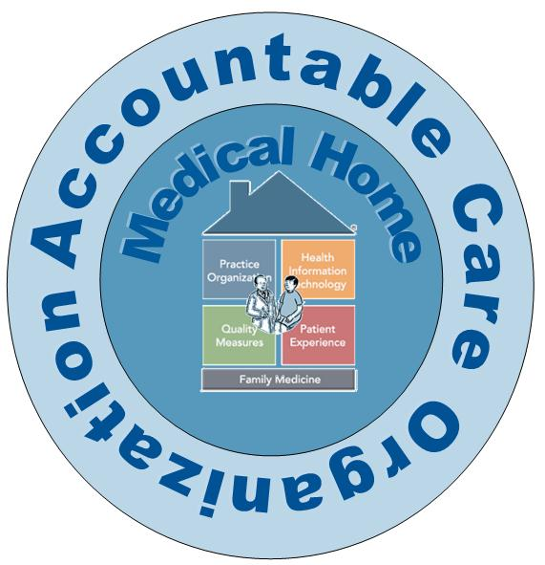

Challenges Faced by an ACO model:

“The Point of Medical Homes, ACOs and Bundled Payments”

1)

2)

3)

The Need for Business Intelligence in Health Care:

Distinguish the difference between “Business analytics” and “Business intelligence”

If you were to present the following slide to a colleague, what would you say?



**Aligning for Value**

Explain the following diagram by identifying “what’s in the collaboration” for each of the identified stakeholders.



**Population Health Management**

Population Health Management is:

Pretend you have been invited to explain to a group of new provider and r payer employees the notion of “Population Health Management”. You may use only one slide- image, presented below. What would you say? Create an outline of your presentation.

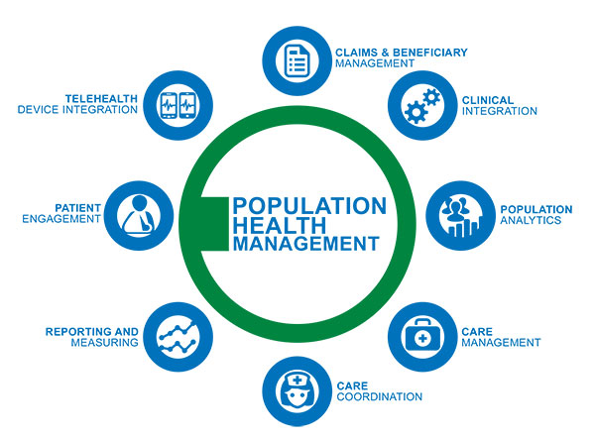

**Implication for you:**

* Rapid change in business model: From volume to value
* New skill sets required:
  + - Collaborative team skills
    - Multidisciplinary approaches
    - “Optimizing costs”
    - Big picture: less about numbers alone and more about viewing the context of the numbers
    - Insight into clinical sciences i.e. professional practice models
    - Clinical professional must help inform business decisions
    - Focus: benefit the business and the Patient

**Notes:**