# Changing the Event Logo in LinkedIn

**Tip 1:**  Have you ever shared your event registration link on LinkedIn and noticed the big blue cvent logo underneath it and you don’t quite like it? (example screenshot below)  
I personally like to pick another image pertaining my event, the chapter logo, event brochure, etc. ... Let me show you how to change that!

Example:

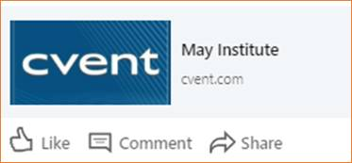

The best marketing is marketing you don't have to do yourself. Follow the steps below to allow your invitees to share your event on Facebook, Twitter, and LinkedIn directly from your event's website.

## In a Classic Event

**1 Access the Social Media Sharing tab.** Begin by selecting your Classic event. Hover over Promotion & Communication and, under Web, click **Social Media**.  
  
**2 Establish what event information will display.** Click **Edit**. To add an image, click **Browse Library...**. Double click the folder, then the file. Don't see your image? Open a folder and click**Add File** to locate the file on your computer or network.

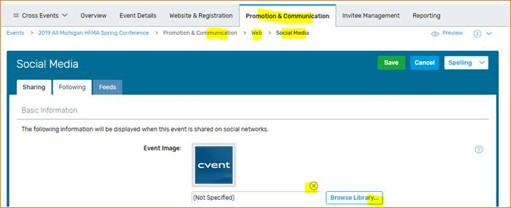

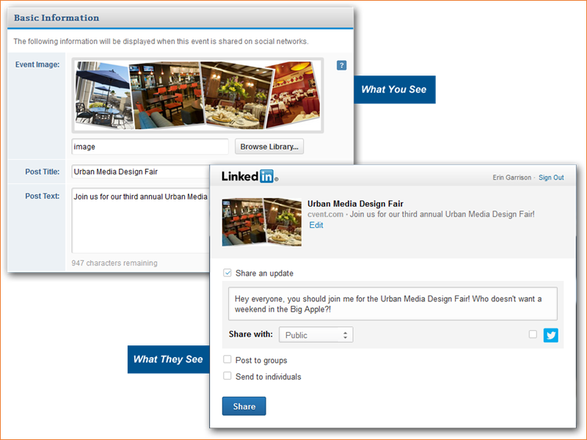

Enter the post's title and text that will display on Facebook and LinkedIn. Under Twitter Post Details, enter the tweet text, then the event's hashtag.

**3 Activate the share bar.** In the Share Bar section, ensure Yes is selected next to "Display share bar," then click Change Placement to determine where the bar will display on your event's website.  
  
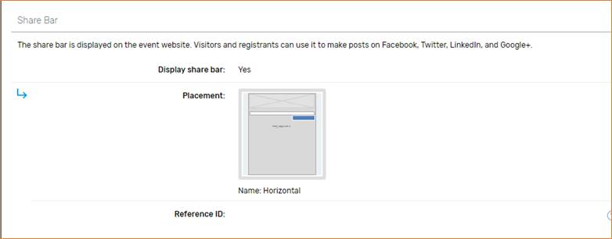

Click **Save**

*That’s it!*