Closing and Archiving an Event
Q: Are there any closing steps you need to do after an event is over and before it goes to archive?
A: There are no further steps. The event will be archived automatically in 90 days.
Or, you can archive it manually before 90 days.

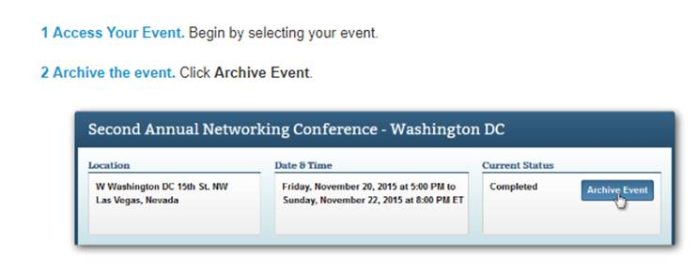
If you are not receiving Ada’s Cvent tips email chapter@hfma.org and ask to be put on the list.

