# Copying and Sharing Event Badges and Certificates

**Tip:**  You don’t need to reinvent the wheel … copying & sharing event badges and certificates is simple — Thanks to Kristen Zebrowski for asking me, and I thought it would be great to share with all of you.   
  
Access the Badges and Certificates page -> Hover over Website and Registration, under Onsite, click badges & certificates. You can share these for other chapters to use (if you want to) and retrieve them from the library when you need them.

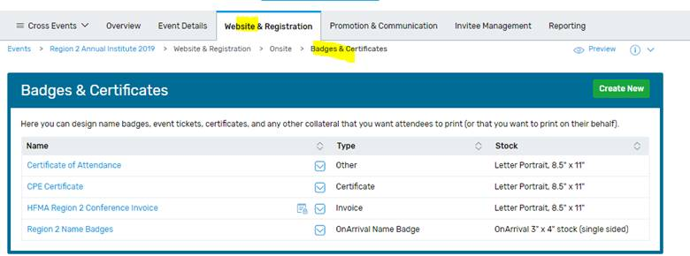

Here is how to share it: Click on your template, under **Actions -> Add to library**

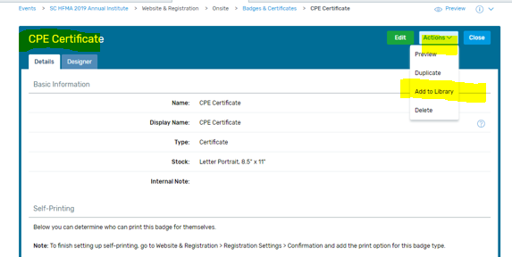

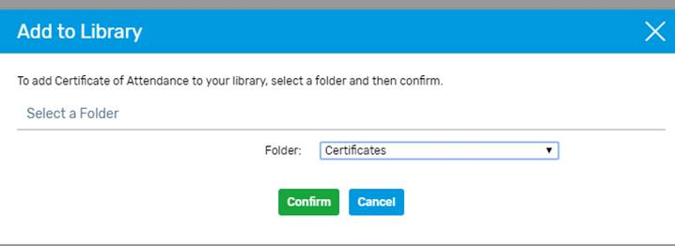

Here is how to Copy a badge or certificate from the library to save yourself time. Small edits might be needed, but I still think it’s a lot easier than starting from scratch.

Click on “create new template” **select 2nd option** from library, and Select the middle option “**Using a badge/certificate from the library”**



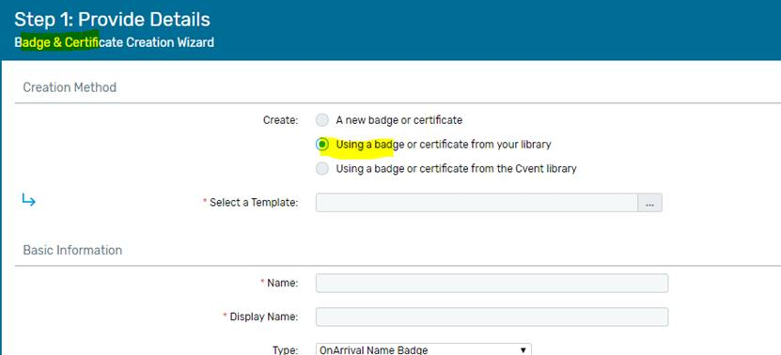  
  
Under the Folder, **select “Certificates”**

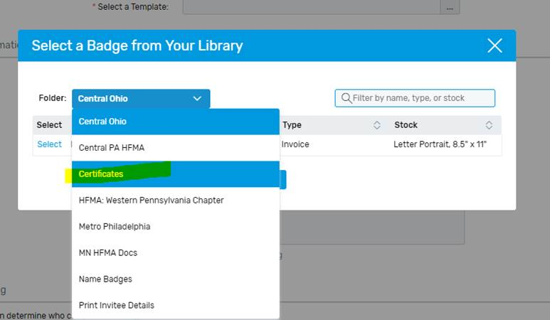

Pick whichever one you need. I’m selecting Reg 2 template to demonstrate, but there are many to choose from …

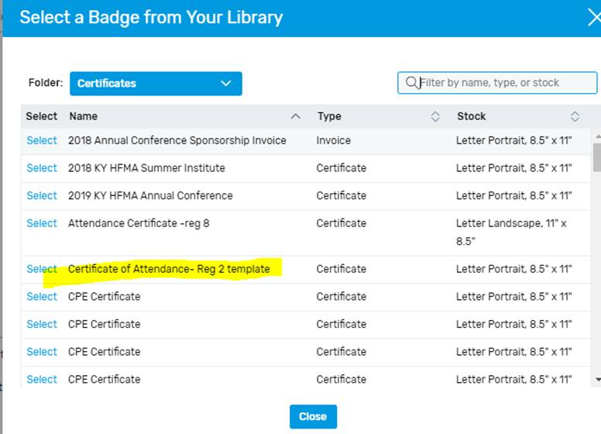

Make any edits you might need and click save. That’s it!

See sample badge on next page.

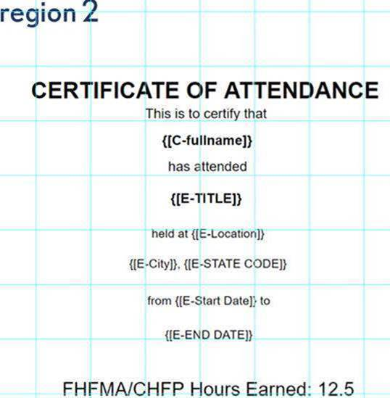

Note: If you already have a badge or template you have been using and it's working out great for you, you don’t need to copy any of these templates, just keep your current one.