Creating an Event Checklist

Mike Rossi (Metropolitan Philadelphis) did it again, he provided us another great tip to share – thanks so much Mike.
- Do you need a checklist to ensure your event runs smoothly?

Create a standardized task list in Cvent. Tasks can be assigned to volunteers and can involve actions to be taken either within, or outside of Cvent.

Make a list of all the critical steps for your events such as when do you build the agenda? When do you start promoting the event? Who is responsible for sponsorship? When is the catering order due to the venue?

Do you have different lists for different types of events? Obviously, two-day events will have more critical steps than a half-day workshop and you’ll have the ability to manage all that in one place. I would suggest starting with the steps that are common to all of your events. In our chapter, we set a goal to complete all agendas at least 10 weeks before an event to give the Cvent team ample time to create the event so it can be launched 8 weeks before the event date. Right there, we’ve identified 2 critical steps common to all our events.

The first step in having the task lists available to you is to set up a template so you don’t have to recreate the list for every event.
Under the Admin link, select Task List Templates from the Libraries sub-menu.
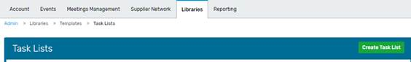
Click the green Create Task List to start building your template.

Give your template a name that starts with your Chapter or Region name to distinguish it and make it easier to find. Enter a description so future Cvent users can understand what the template was for (Task list for 2-day events, Task list for half-day workshop, etc.) I would recommend not limiting who can see your task list and would urge you to exercise caution if you are viewing another chapter’s task list to make sure you don’t make changes to it! When complete, click the Save button.
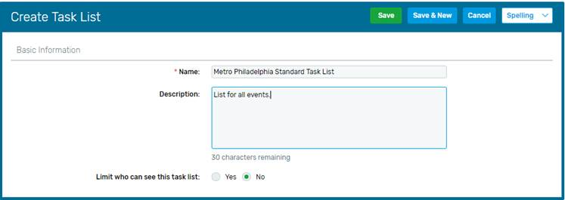
After clicking Save, you are ready to start adding tasks by clicking the Tasks tab

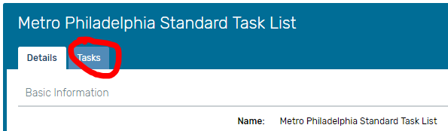

This will bring you to your list of tasks associated with this template. Click the green Create button to get started on building your tasks. This preps the list and adds a Create Task button in the lower left of the screen. When you click that, you will be able to start adding tasks.

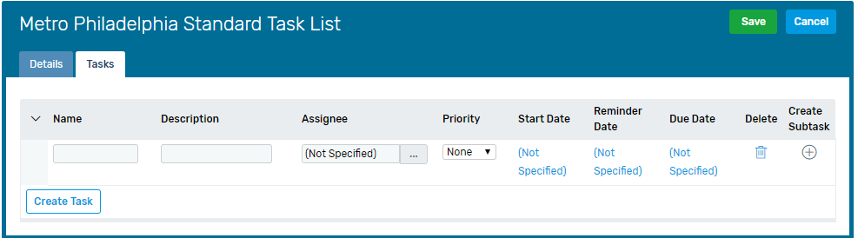
Enter a name for your task: Complete Agenda
Enter a brief description: Event committee to give completed agenda to Cvent team.
For the time being, leave the Assignee blank. When you add the template to an event, you can then assign the task to a specific person.
Priority is completely optional but could be helpful in identifying those items that should be addressed first.

Start, Reminder and Due dates must be entered. Each must be different, and they should be sequential…Due Date happens after Reminder Date which happens after Start Date. You have the option of setting the dates relative to certain event dates. If you want the agenda completed 10 weeks before the event, I would set the Due Date to 70 days before Event Start Date, the Reminder at 77 days before Event Start Date (one-week notice) and the Start Date at 84 days before the Event Start Date.

Once complete, click Create Task to enter your next task, or click the “+” under Create Subtask if there are multiple steps that you want to identify for a single task. After completing all your tasks, click the green Save button at the top of the screen. Now, you’re all set to add the Tasks to an event and assign them to people to get them completed.

Adding (and Assigning) Tasks in an Event
The first step to being able to utilize tasks is to enable the feature when creating an event, or by editing the event configuration after the event has created.

Check off the box next to Task List to enable the feature:
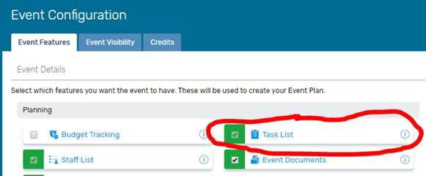

Tasks are accessed under the Event Details tab. If you don’t have any task templates created, you can dive right in and create tasks specific to the event by clicking the Create Task button. Assuming you created a template (or two), click the Apply Task Template button to add your template to the current event.

Locate your template from the list and click Select.
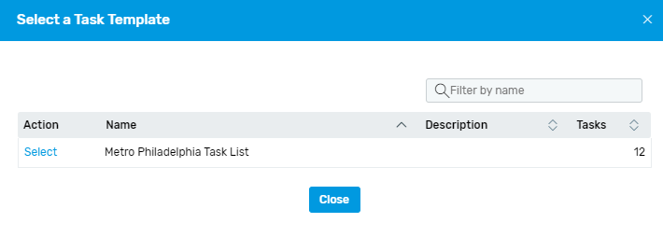If you did not set your Start, Due and Reminder dates correctly, the template will not apply and Cvent will display an error message. Unfortunately, it won’t tell you which task is causing the problem, so you will have to go back to the template and troubleshoot line by line.

Once you have successfully imported the task template, you can now assign the tasks, edit the tasks, or even delete them!

To edit any single task, either select Edit from the drop down next to the task name, or click the task name.

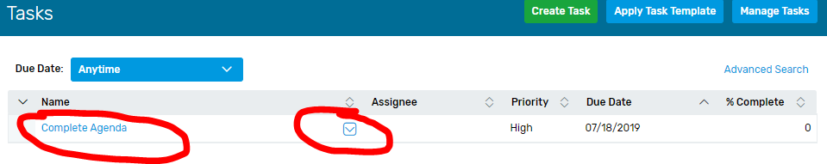
Before attempting to assign tasks, you need to first make sure you have identified the “Staff” for your event (similar to tasks, there is an option to include Staff in the event configuration). Staff can be entered by going to “Staff” under the Event Details tab.
Click the green Create Staff Member button to add the people who will be responsible for completing the tasks (as well as people you might want attendees to contact with questions). Our chapter usually lists the event chairs and the registration coordinator. You can add as many as you want and you have the option to select which people will be displayed on the website.
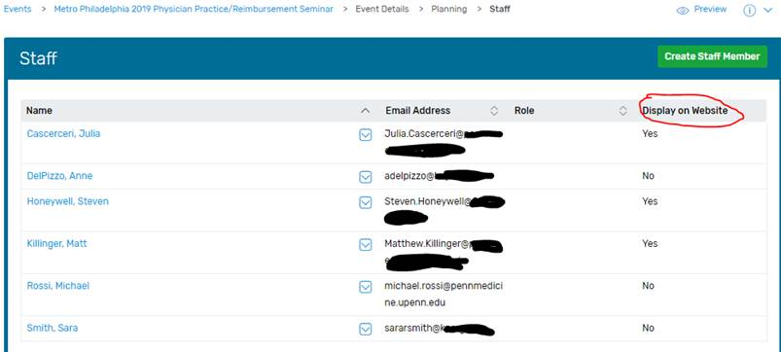
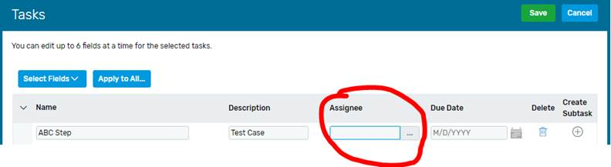
After setting up your staff, return to the Tasks page to assign tasks to the relevant staff. You can assign each task to only one person and the assignment can be by either clicking the task to edit it, or by clicking the Manage Tasks button to open all of the tasks for editing at once. Click within the Assignee field to open a window to select someone to assign that task to. The system will default to Users, so you will have to select Staff Member from the dropdown. Click the Select link next to the person you want to assign the task to.
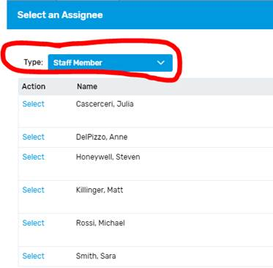
After completing your assignments, click the Green Save button and all assignees will receive emails indicating they have been assigned a task.

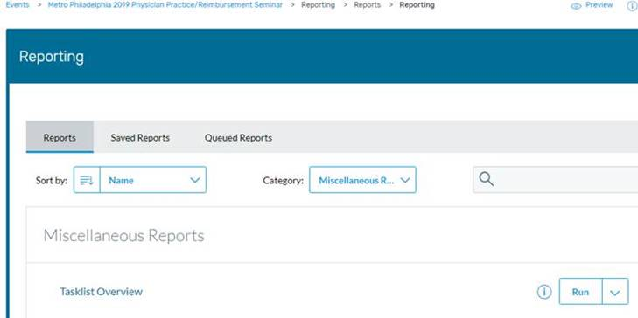
As tasks are completed, return to the task list and edit the task to add internal notes about the progress of the task, or mark the task as complete. Want to share the progress with your team? There is a report called Tasklist Overview that you can run and download:

Good luck and happy planning!

If you are not receiving Ada’s Cvent tips email chapter@hfma.org and ask to be put on the list.

