Creating Education Credits
Awarding credits is a great way to reward your registrants for attending a training seminar or continuing education course. Planners have the option to award credits for the entire event, for specific sessions, or both. These credits can be automatically applied as soon as the registrant checks in or you can assign them yourself. As a final touch, consider including the credit totals in your attendees' certificates.
1. Activate the Credits feature. Select your event. Hover over Event Details and, under General, click Event Configuration. Click Edit.
Scroll down to the bottom and check Credits in the Promotion & Communication>Other section. Then click Save. A new tab appears.
2. Award credits for an entire event. You can award credits to registrants who attend an event, regardless of the sessions they sign up for. If you just want to award credits for sessions, skip to Step 3.
Select the rightmost tab at the top of the Event Configuration page, Credits, then click Edit.
All the credit types you added in Admin will appear. Enter a credit value. You can also add an expiration date. Once this date passes, no one will earn anymore of these credits. Earned credits, however, will never expire.
To determine who automatically gets awarded credits, select Registrants (when the event ends), or Participants. If you select participants, establish if they'll be awarded the credits once the event ends or when they're marked as a participant. To award the credits manually, select No One.
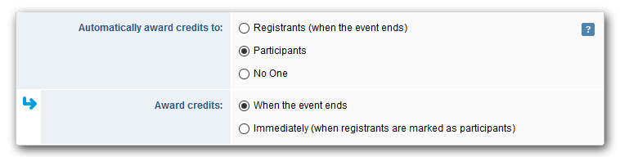
If you want to limit credits to specific registration types or have multiple credit types, click Yes beside "Limit which registration types can receive these credits" and select the registration types that can earn credits.
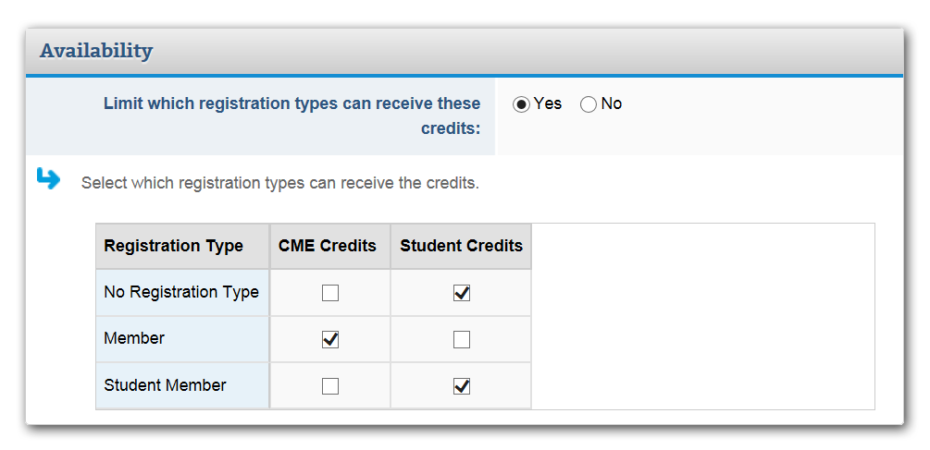
Click Save.
3. Award credits for optional sessions. You can also award credits to registrants who attend specific optional sessions. Hover over Event Details and, under Agenda Items, click Sessions.
Open a session by clicking its name. The Details tab opens by default. Click the tab to the right, Credits, then Edit.
All the credit types you added in Admin will appear. Enter a credit value. You can also add an expiration date, if applicable.
To determine who automatically gets awarded the session credits, select Registrants (when the event ends), or Participants. If you select participants, establish if they'll be awarded the credits once the session ends or when they're marked as a participant. To award the credits manually, select No One.
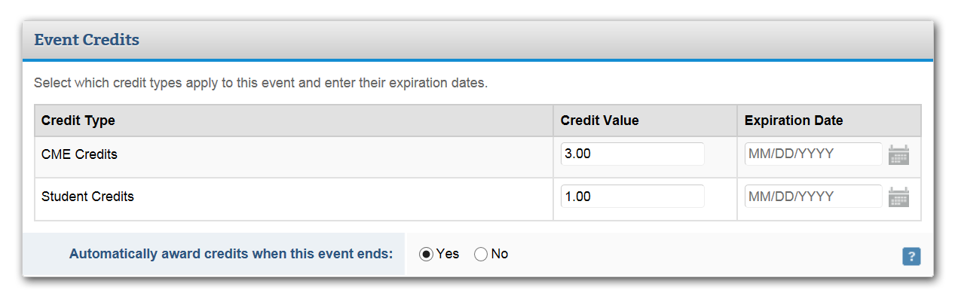
If you want to limit credits to specific registration types or have multiple credit types, click Yes beside "Limit which registration types can receive these credits," and select the registration types that can earn credits.
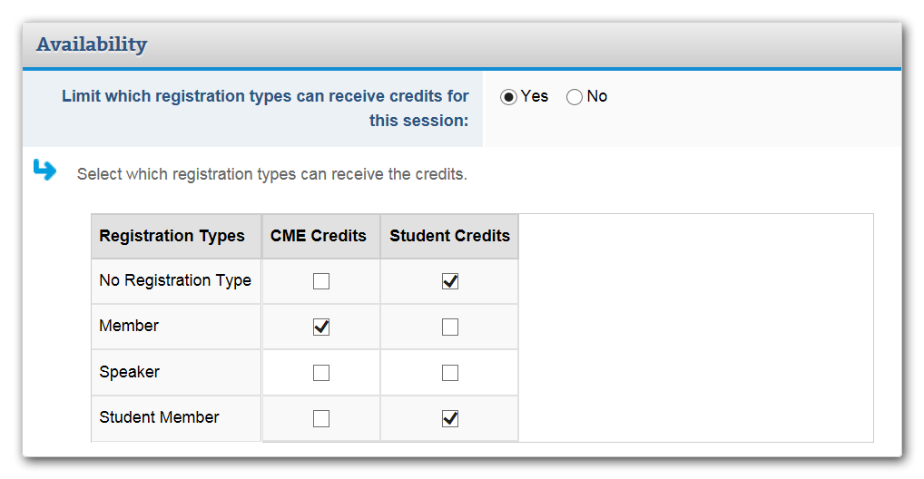
Click Save. Repeat this step for other applicable sessions.
Adding Credits to Certificates
Add credits to certificates. Add registrants' credit totals to their certificates automatically by inserting a data tag.
To do so, hover over Website & Registration and, under Onsite, click Badges & Certificates. Edit the certificate you've created by clicking the to the left of its name and selecting Edit Design.
On the left, click the Data Tags tab next to the Components list and type credits in the search box.
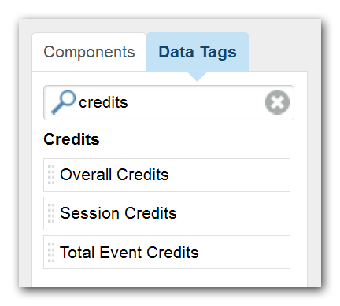
Drag and drop one of the data tags onto your certificate. Your choices include:
- Overall Credits displays all the credits the registrant has earned across events. Once you drop the data tag onto the certificate, you can select a specific credit type.
- Session Credits displays the credits the registrant earned for a particular session. Once you drop the data tag onto the certificate, you can select a specific session or credit type.
- Total Event Credits displays the credits the registrant earned for this event.
Once you drop the data tag onto the certificate, you can choose a credit type.
- Credit Transcript - Displays a table of credits awarded to the registrant, broken down by activity and credit type.
Customize the color, font, and size of the data tag text in the Properties section on the left.
Once you're done, click Save.

