Designing your event’s website

Tip: Select your website layout/theme and change body text, section header, background colors, and much more…

Hover over Website & Registration, under Website, click Event Website.
After selecting your preferred layout, adding a header or your chapter logo, Click save and go to the next tab Theme.

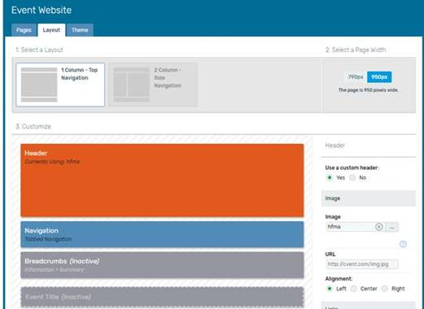
Select your preferred Theme from the dropdown menu…some fun options to choose from.
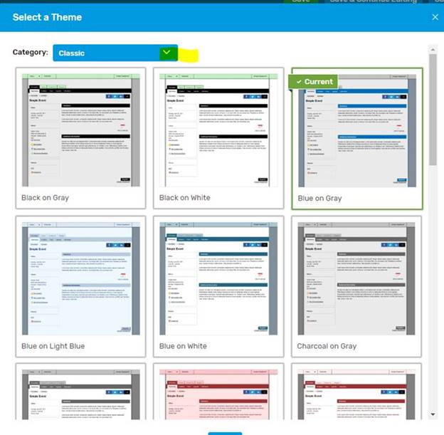

Feel free to select a different register button color and progress bar to catch users attention.

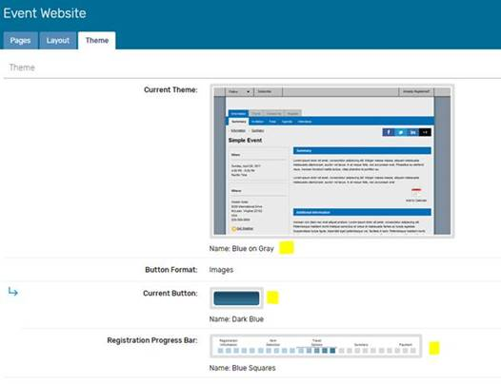
Change the color scheme. Scroll down to the Website Design section. Unless you're familiar with CSS, Basic Mode is recommended.

Changing Colors in Basic Mode – please see attached PDF for additional guidance on what each field is referencing.
→ Click Save
→ Preview the event

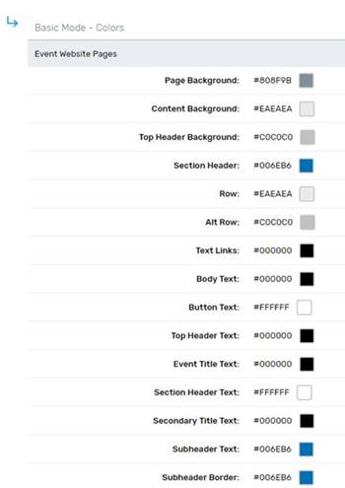

If you are not receiving Ada’s Cvent tips email chapter@hfma.org and ask to be put on the list.

