Ada’s Tips: Event Emails
Tip: Make sure you select the correct email before launching your event. (if you already launched it, you can still go back and change it)

Verify the email by going to Promotion & Communication > Email > Event Emails Any active/green option, should have the correct email. The invitation and confirmation emails are the most important ones. I see many events with Cvent@hfma.org listed as the email address. That means that if your attendees reply and have questions for you, they most likely will not get an answer right away. Cvent@hfma.org was the default email address entered when we launched Cvent and we had no chapter planners set up, but the email in your event needs to reflect your preferred email so you can quickly answer any questions your attendees might have.

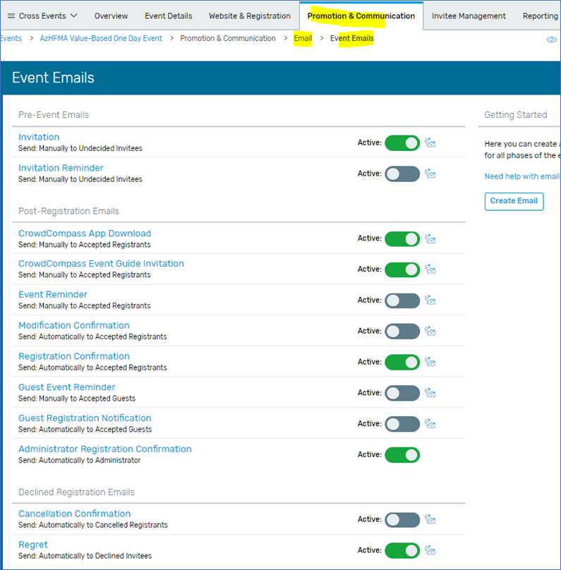

For example: Click on the invitation link, from email address: please select your email from the drop-down menu. If your email is not listed on the dropdown, please let me know and I’ll add it.

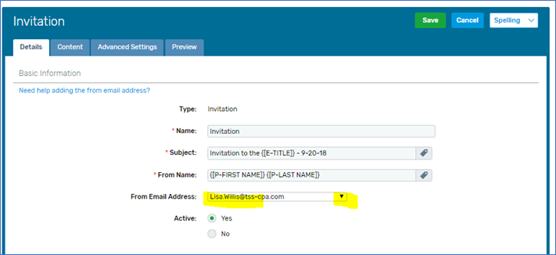
Follow the same steps for the other options such as Registration confirmation, etc.

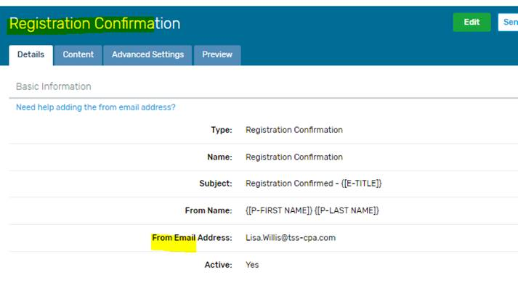
If you are not receiving Ada’s Cvent tips email chapter@hfma.org and ask to be put on the list.

