Events Without Registration
If you had events where registration was NOT handled from Cvent (it could have been a webinar, conference, co-sponsored etc.) but you still need it to count for DCMS hours, please enter them into Cvent as “No registration required events”.

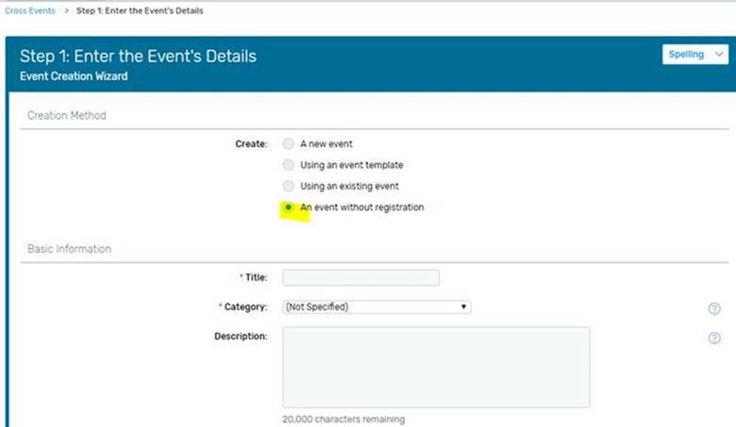
You can do that by clicking “Create an Event” → select the 4th option – “An event without registration” and follow the steps. They’re simple to create, just need Title, Category, Date, and the Custom fields below. Hit Finish!

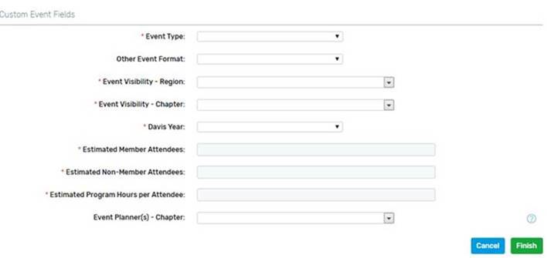
Once finished, the event will look like the screenshot below, status is No registration required.
Pending-status events are NOT going to pull into reports. Pending means you’re working on it, the event has not happened yet, or you’re just not sure if the event will even take place.

If you notice your events are not in DCMS reports, double check their status in Cvent. Let us know what’s missing and we can help you out, I promise!
After you’re done with the “no reg required” events, please send us the attendee list.

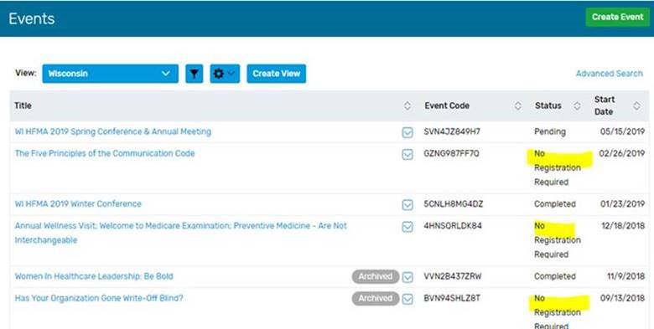 If you are not receiving Ada’s Cvent tips email chapter@hfma.org and ask to be put on the list.

