Inviting People to Take the Feedback Survey

Once you've set up the Standard Feedback or the OnArrival Feedback (Beta) survey you'll want to make sure all attendees know how to access it. Fortunately, there's a pre-built email template to do just that.
1. Access the Post Event Feedback email. Begin by selecting your event. Hover over Promotion & Communication and, under Email, select Event Emails.
If your event has multiple invitation lists, select one from the dropdown at the top.
Scroll down to the Post-Event Emails section and click the email's name.
NOTE: If you'd like feedback from your registrants' guests as well, there's another template intended for that. To modify it, click Guest Event Feedback.
2 Adjust the email settings. Click Edit. Activate the email by clicking Yes next to "Active."
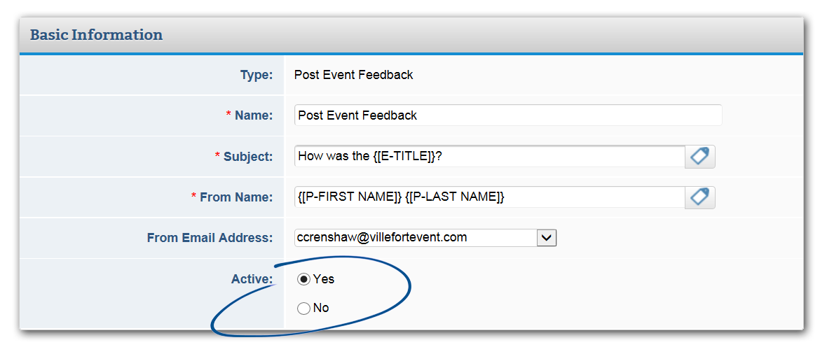
If necessary, edit the Name, Subject, and From Name fields.
3 Schedule the email. Want to "set and forget" the email? In the Send Settings section, next to “send this email," select “At the following data and time.”
Enter a date, time, and time zone. Unless you're allowing feedback to be collected before the event is over, ensure the date and time is after the event end date (listed in Event Details > General > Event Information) has passed or the email will not send.
Scheduling your emails at least an hour in advance is recommended. Also keep in mind that delivery can be impacted by how many messages you and other users are sending.
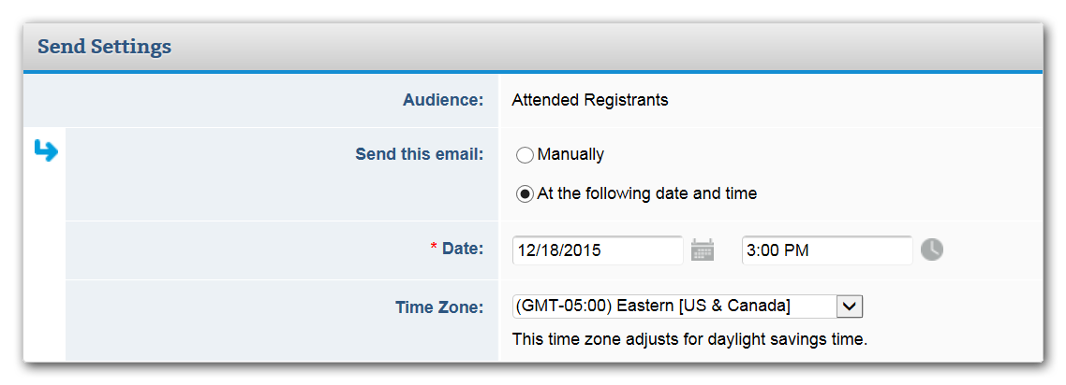
NOTE: You can create a reminder email to go after this one. Just select the action “duplicate.”
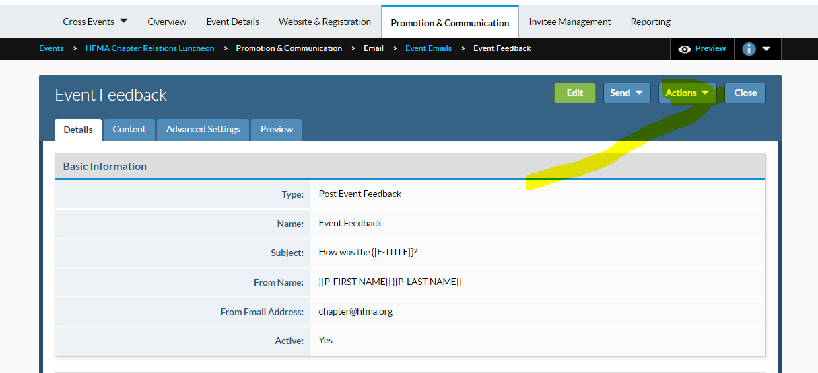

Continue on next page.
Select the audience type "Registrants who did not respond to the feedback survey." Make sure you're sending it on a later date than this one.

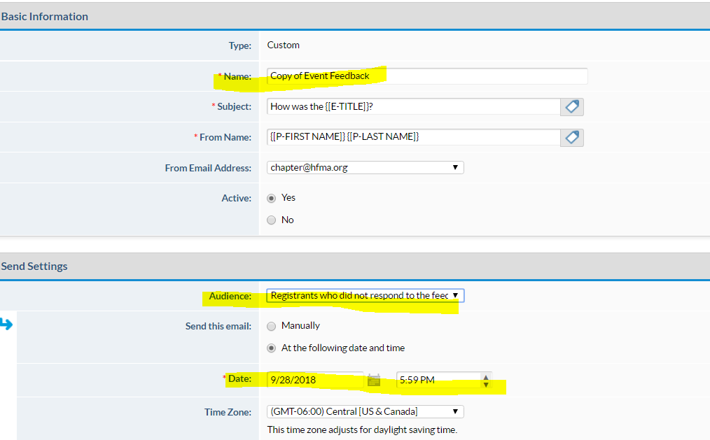
Once you're done, click Save.
4 Edit the template, if necessary. Click the neighboring tab, Content, then click Edit.
Feel free to make any changes to the content, but make sure the survey link data tag ({[E-FEEDBACK LINK]} or {[E-SURVEY-LINK]}) remains. This data tag gives recipients a direct link to your feedback survey.
Once you're done, click Save.
5 View your registrant's responses. If you're using the Standard Feedback survey, check individual registrants' responses by going to Invitee Management > Invitees & Registrants > Answers and choosing Feedback Survey from the dropdown. You can also view answers in bulk by going to Reporting > Reports > Standard Reports>General Reports and selecting either Survey Question Summary or Survey Question Details by Registrant.
Using the Event Feedback (New) survey? Find all the reports you need in Website & Registration >Surveys> Feedback Survey > Reporting.

