Managing Contact Group Information
Have you noticed sometimes your existing contact group information was changed? How and Why? Or maybe, you didn’t notice…
If you import your contact file, another chapter might do the same and if they’re not careful, they can update that contact record without realizing it just by selecting the 1st import method “Insert new contacts and update existing contacts”.
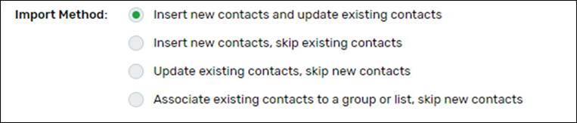
Since each contact is identified by email address and the same record can live within multiple contact groups from different chapters, please be mindful when importing and which import method you select.

When you’re selecting the 1st import method, is important not to overwrite each other’s stored data with a blank.
When mapping fields from your import file to Cvent Fields, select DO NOT Import for the fields you do NOT want to update (the most important fields to import are: First Name, Last Name, Email, Member ID, Region#, and Chapter Name) and that’s all you need to map, for the rest of the fields select “do not import” from the dropdown menu (screenshot below)

FYI: Import methods description:
- Insert new contacts and update existing contacts allows you to add both new contacts and update existing ones in your Address Book. This is the default selection.
- Insert new contacts, skip existing contacts adds additional contacts without changing information already in your Address Book.
- Update existing contacts, skip new contacts revisits old information in your Address Book without adding additional contacts.
- Associate existing contacts to a group or list, skip new contacts lets you assign contacts to contact groups without altering their information.

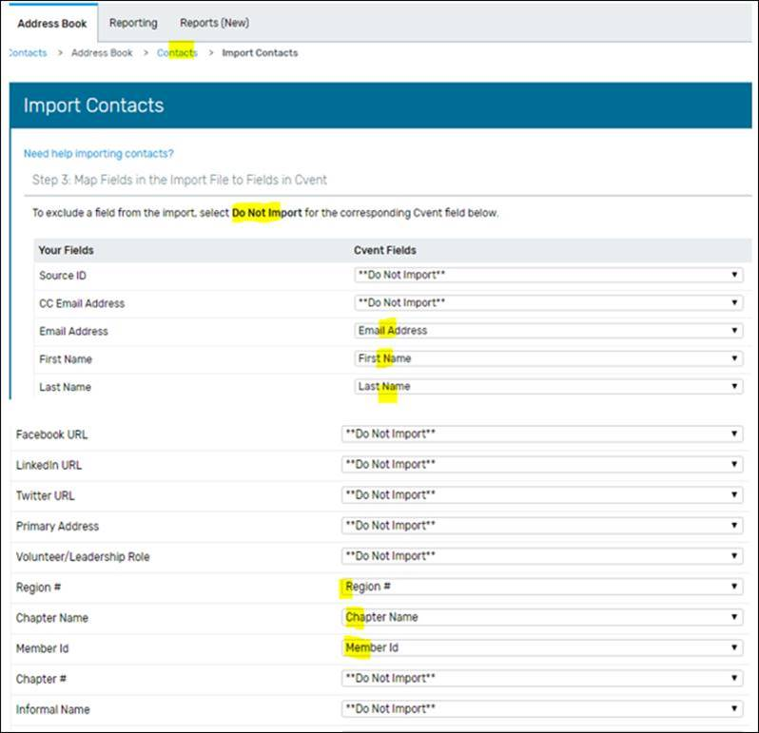

If you are not receiving Ada’s Cvent tips email chapter@hfma.org and ask to be put on the list.

