Networking events - how do you enter them, or why are they’re not showing on the Dashboard report?

As you know, you need 4 networking events per year (pretty much all the chapters have at least 4 per year, so this metric is very easily met and nothing to worry about)

There are 2 ways to enter them.
- Enter in Cvent as a stand-alone event with ‘No registration required’ and category ‘Networking’ OR if you don’t want to do this from scratch, just pick one of our templates for “reporting networking events” (screenshots below)
- You can add a Networking session in any of your standard events, but make sure the category is “Networking”

Option 1. Select Create Event:
On the Enter the Event’s Details Page select Create Using an Event Template then click on the three dots next to the template field.
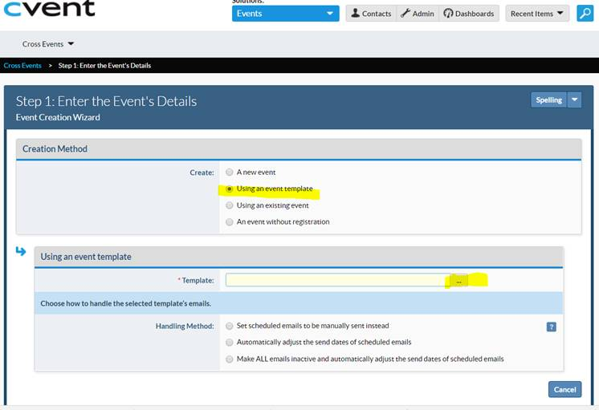
Select Report Networking Events, then update the Basic Information, When, Where (optional), Event Planner, and Custom Event Fields.
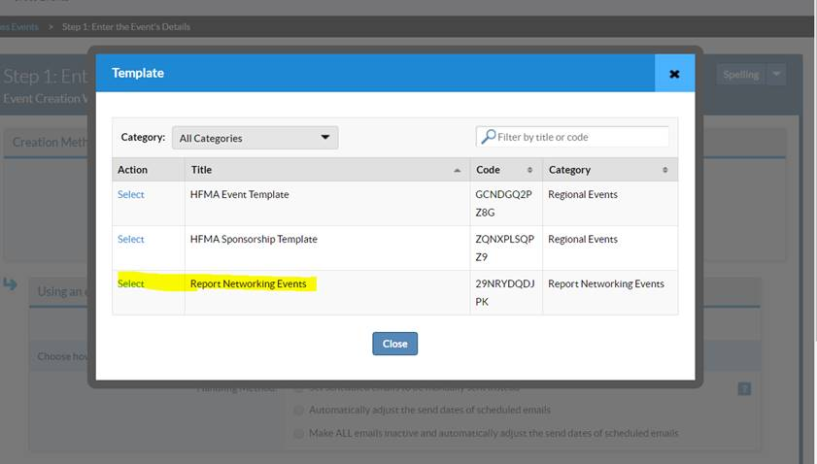

Option 2. Create a session for Networking Category; example below shows the session which is included on this big event for Spring conference. You can include this session on any event.

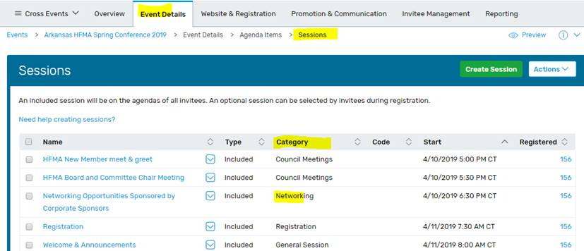

That’s all you have to do for networking, and we will handle the rest…which leads me to the next question why these events are not showing up on the Progress report?
Answer: Some networking events are uploaded into the progress report, but we are a little behind uploading the new data. We're working with our IT team to update this and appreciate your patience.

If you are not receiving Ada’s Cvent tips email chapter@hfma.org and ask to be put on the list.

