Selecting the Correct Merchant Account for Your Event

Have you ever wondered why you have 20 people registered and zero dollars in your bank account?

Tip: Make sure you’ve selected the correct merchant account. 😊

This issue can happen when you copy another chapter’s event, or you use an event template to make your life easier, which can save time if the new event has similar agenda, website design, or registration process. Just remember, any features, any settings enabled in the original event, including the merchant account will be added to your new event if you rush through the event creation wizard.

The screenshot below shows the 2 methods of event creation that you need to be careful:
--Using an event template
--Using an existing event
Always double check by going to Event Details -> under general click Event Configuration -> click Edit under Fees and make sure the correct merchant is selected (screenshot below)
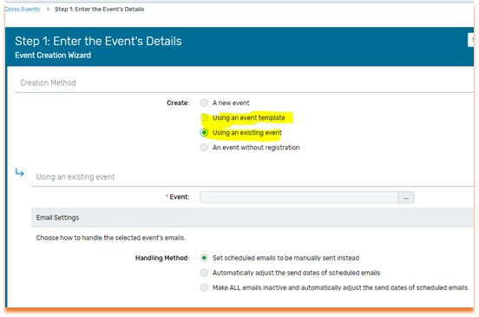

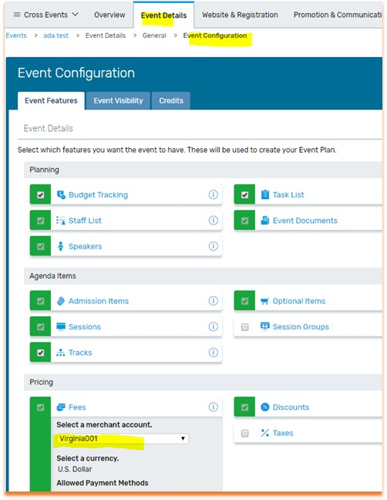
If the wrong merchant was selected, please contact us and we’ll work with Cvent ecommerce dept. We might have to close the event temporarily for about a half-hour, fix the issue, and re-open the event with the correct merchant. You will not lose any event information, everything remains the same, the registration link etc. Then we will help you figure out the funds transfer between merchant accounts. It’s fixable but will take some time to get it all straightened out.
If you are not receiving Ada’s Cvent tips email chapter@hfma.org and ask to be put on the list.

