Sending the Feedback Survey Email

Tip: Before sending out the Feedback Survey email, please make sure the “From Email Address” and “Audience” is correct (screenshot below)

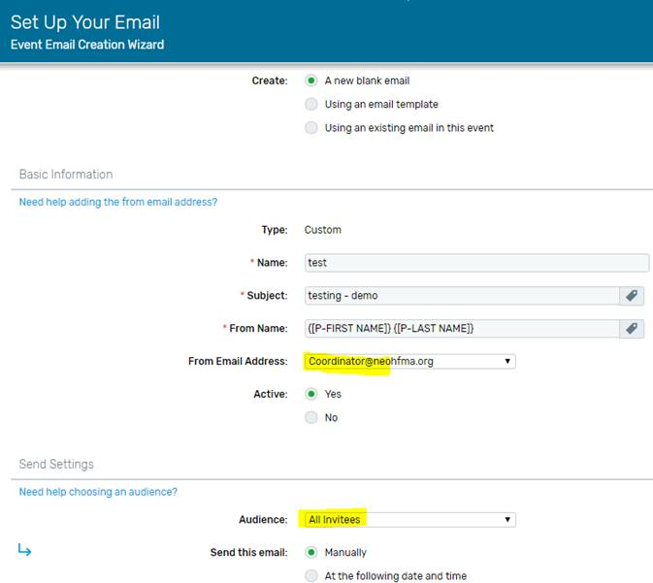
Make sure you have the right Audience. The most commonly used are: Accepted Registrants and Attended Registrants.

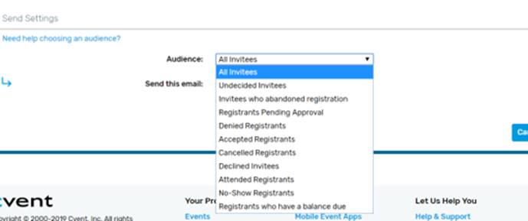

Description of all Audience types for your reference:
• All Invited – Everyone added to your invitation lists.
• Undecided Invitees – An invitee who opens the email but has not RSVP'd to attend the event or not.
• Invitees who abandoned registration – An invitee who begins registering but does not click Finish. This audience type will not work when manually sending an email.
• Registrants Pending Approval – An invitee who registered for the event, but is awaiting your approval. This audience type will not work when manually sending an email.
• Denied Registrants – An invitee who registered for the event, that you did not accept.
• Waitlisted Invitees – An invitee who has been added to the event waitlist, but is waiting for a spot to open up.
• Accepted Registrants – An invitee who successfully registered for the event, or, if you have Registration Approval enable, that you have approved.
• Cancelled Registrants – An invitee who registered for the event, but then cancels.
• Declined Registrants – An invitee who has RSVP'd "No" to the event.
• Attended Registrants – A registrant who has been marked as a participant. (See below for more details)
• No-Show Registrants – An invitee who registered for the event, but did not attend, and, therefore, was not marked as a participant. This audience type will not work when manually sending an email.
• Registrants who have a balance due– An invitee who has registered for the event, but has not paid their amount due. This audience type will not work when manually sending an email.
If your selected Audience is Attended registrants, please make sure they’re checked in before sending the evaluation email. There are 3 ways to check in:
- onArrival onsite (if you purchased or rent by CVent)
- Free basic OnArrival mobile app
- Check in manually in Cvent by marking them individually (Steps below)

Marking Participants Individually
1 Access the Participation page. Begin by selecting your event. Hover over Invitee Management and, under Assign, click Participation.
2 Mark the participants. Note the Participant column. A Yes indicates the registrant showed up. A No means they did not.
Need to narrow the list? Click Participant Search in the upper right, filter by invitee status, participant status, or session, and click Search.
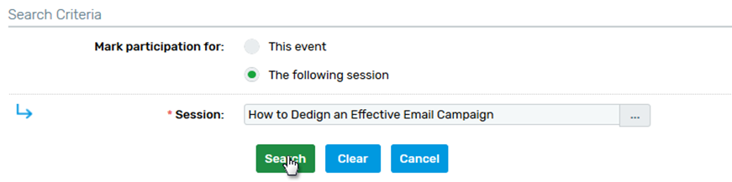

To mark individual registrants as participants or no-shows, check the boxes to the left of their names. You can select everyone at once by checking the top box in the checkbox column.
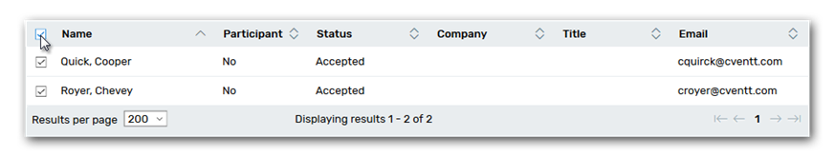

Click Update Participation. The No will be changed to Yes, and vice versa, for everyone you selected.

If you are not receiving Ada’s Cvent tips email chapter@hfma.org and ask to be put on the list.

