We’ve gotten requests about the new Chair’s Theme so I thought I’d include the link to that page as well. https://api.hfma.org/Chapter-Leaders/Chairs-Theme/

Ada’s Tip of the Week: How not to see other chapter’s events on your Cvent account.

Let me explain why that happens and how to fix it. When you set up your events, please make sure to go to Event Details -> Event Information
Custom Fields. Event Visibility must be set up correctly. For example, the screenshot below shows a Region 2 event which is marked correctly. Because it’s a regional event, all the chapters within the region should be listed.

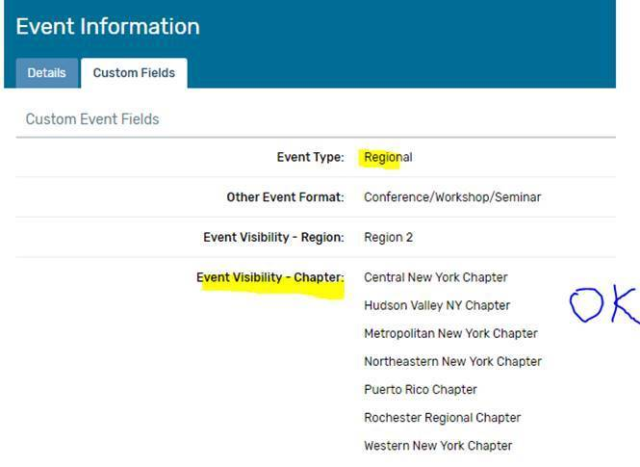

Below is another correct way to handle event visibility, this example is for a single-chapter event, so no other chapters should be listed:

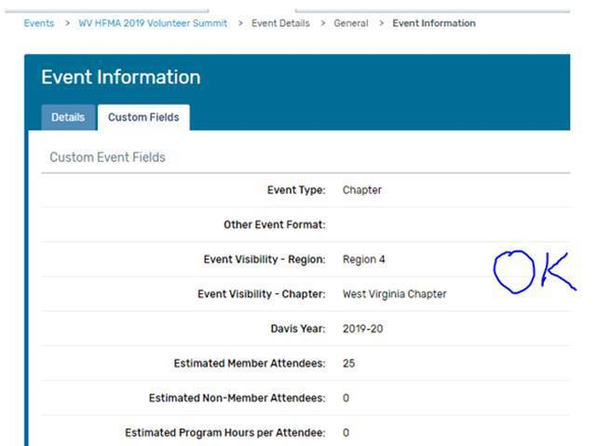

Below is the incorrect way of setting up a single-chapter event. This example below is a chapter event so only the hosting chapter should be listed under visibility—not the entire region.

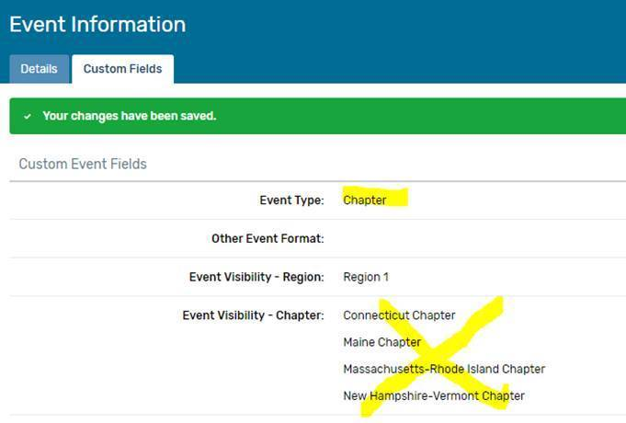
Below is another incorrect set up that we’re seeing…
It says a Multi-Chapter event, but only one chapter is selected. If you set up an event this way, you may get an email asking you to confirm whether this is a chapter event with the wrong event type selected, or, if it is a multi-chapter event, which other chapters should be visible.

The chapters listed in the event visibility are the chapters that will receive DCMS credit for the event hours, so you want to make sure you share the hours only when it’s appropriate.

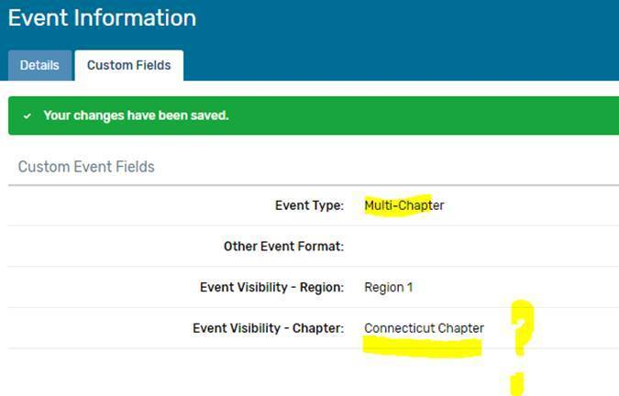

Hope these examples make sense so we can all keep our Cvent account more organized and easier to manage.

