Setting up a Sponsorship Event

Tip 1. Set these up as Admission Items by going to Event Details tab -> Agenda Items -> Admission Items ! No registration types needed. There is no limit on admission items.
See example below:

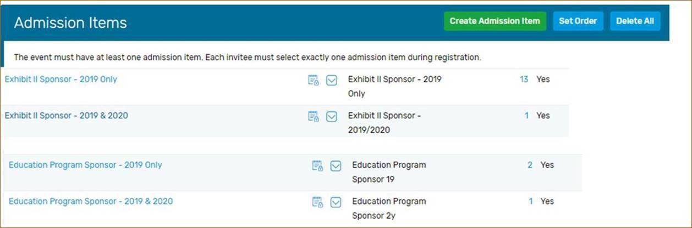

Tip 2. There is no DCMS hours for sponsorship events, so please make sure you enter zero under your estimated program hours per attendee.

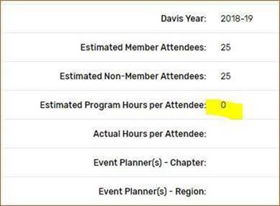

Tip 3. This applies to any type of event, if you’re setting up a chapter event and only your chapter receives the DCMS hours please make sure you select your chapter only under event visibility field. If you select other chapters, I’m assuming the rest of the chapters were involved and they receive hours as well, so I might follow up with you to confirm the visibility which can delay the importing of hours into reports. 😊
Example below shows the correct way.

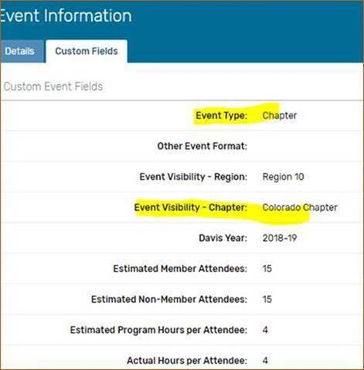

If you are not receiving Ada’s Cvent tips email chapter@hfma.org and ask to be put on the list.

