Entering a stand-alone networking event with no registration fee;
Select Create Event:
On the Enter the Event’s Details Page select Create Using an Event Template then click on the three dots next to the template field. 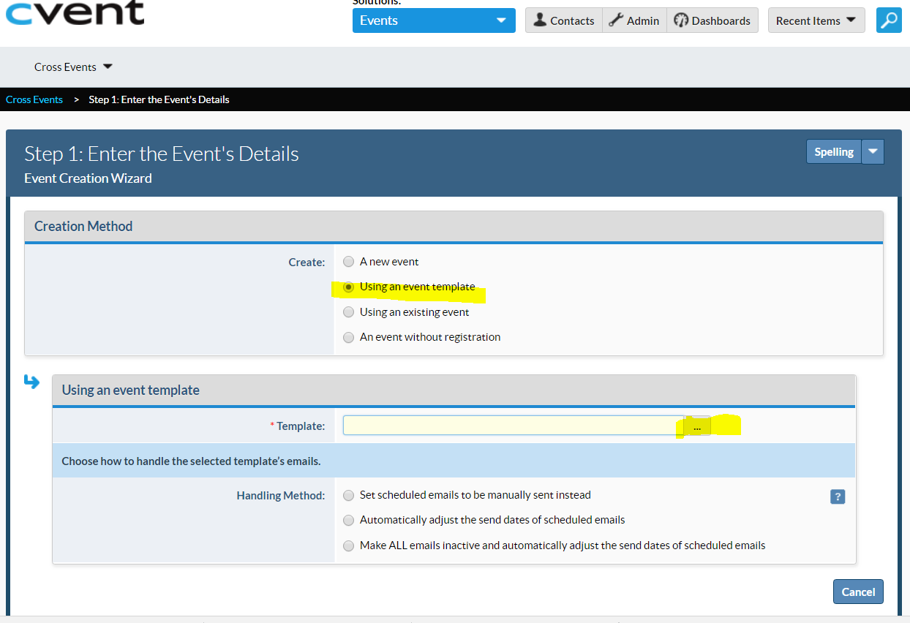
Select Report Networking Events, then update the Basic Information, When, Where (optional), Event Planner, and Custom Event Fields. 