SMART Goal Worksheet

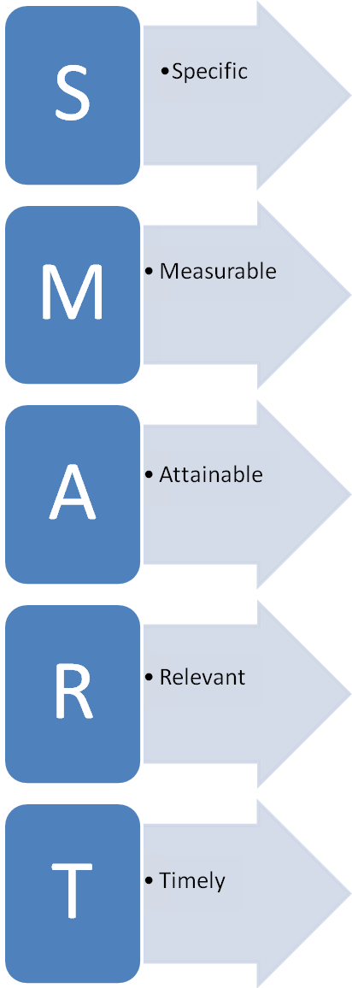 | What do you want to accomplish?
 | How will you know you’ve accomplished your goal?
 | How can you accomplish your goal?
 | Is it worth the effort to accomplish? Why?
 | What is the deadline to accomplish your goal?

SMART Goal Worksheet

What do you want to accomplish?
How will you know you’ve accomplished your goal?
How can you accomplish your goal?
Is it worth the effort to accomplish? Why?
What is the deadline to accomplish your goal?

