Testing Your Event

Moving to Test Mode
Moving an event to Test Mode allows you to accept up to 100 test registrations and send up to 100 emails. Take full advantage of this to guarantee everything is customized to your needs before opening your site to invitees. Once an event is launched, all registrations, including those that were denied approval or cancelled, will count towards your contract number.
1. Access the Overview page. Begin by selecting your event.
2. Move your event to Test Mode. Click Move to Test Mode.
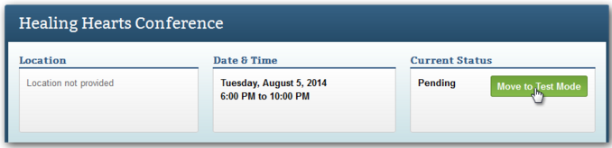
A confirmation screen will appear. Click Confirm.

Using Testing Scenarios
After moving your event to Test Mode, you can create unique testing scenarios to quickly evaluate different aspects of your event. Check the invitation that exhibitors receive, view your website through the eyes of a speaker, or experience registration as someone not in your Address Book. Best of all, you don't have to assess all that hard work yourself. You can get someone else to do it for you.

Testing the Event Yourself
1. Customize your test profile, if necessary. Click My Profile in the top right. The User Information tab will open. Click the rightmost tab, Test Profile, then Edit.
A test profile is used exclusively for mock data during test scenarios. Once you initiate the test, the contact information entered here will be automatically pulled into the appropriate fields.
2. Access the Overview page. Under Solutions at the top of the page, select Events, then open your event by clicking its name. Click Perform Test.
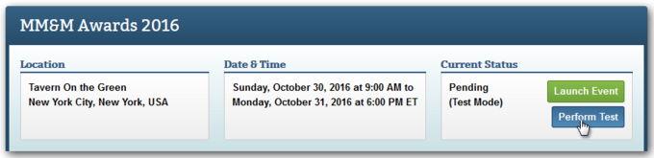
3. Set the parameters. Choose what area of the event you want to test. Your choices include:
  - Email - Do not use this parameter. You will send your invitation through Marketing Cloud.
  - Website – Choose the generic weblink option and select a starting page.
  - Registration Process - If arriving to registration from a path-specific weblink, simply select the registration path. When you initiate the test, registration opens in a new window. Getting an error message? Weblinks won't allow you to register twice. Choose Cvent Email to get around this.
  - My Registration - Select a test registrant. You must have at least one to test the My Registration page.

Sending Scenarios to Others
1. Add test users, if necessary. Want to send these scenarios to individuals without access to Cvent? You'll first need to add them as Test Users. There is no charge to add test users when you create your event. Email the test user's name and email address to chapter@hfma.org with the subject line "Create a test user." Make sure you include your chapter name, so we know where your test user should live.
2. Access the Overview page. Under Solutions at the top of the page, select Events, then open your event by clicking its name. Click Perform Test.
3. Specify the recipients and set up the test email. Select “Email test scenarios to other people.” Choose the From Email Address. Then, click Add Recipient.
Choose Account User or Test User from the Type dropdown, check the box next to the appropriate user, and click Save.
4. In the Scenarios section, choose what area of the event you want them to test. Just click Add Scenario... and your choices include:
Email - Do not use this parameter. You will send your invitation through Marketing Cloud.
Website - Choose the generic weblink option and select a starting page.
Registration Process - If arriving to registration from a path-specific weblink, simply select the registration path.
Explain the scenario to those testing in the Description textbox. Click Save.

NOTE: One is never enough. You can send recipients up to 10 scenarios at once.
5. Send the test email. Send the test email. Click Start Test.

Event Launch
Launching Your Event
Upon clicking Launch Event, the event will be moved to Active status, all test registrations will be removed and each accepted registration from here on will incur a fee.
You can now process online payments. Admission items, sessions, optional items, tracks, and any associated fees can no longer be deleted. However, you can prevent them from appearing during registration by deactivating them.
1 Access the Event Status page. Begin by selecting your event. Hover over Event Details and, under General, click Event Status.
2 Activate your event. Click Launch Event.
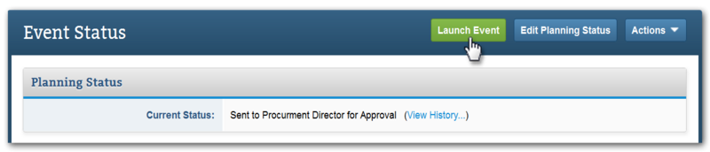
Select whether to keep or remove all email data used during Test Mode, then click Confirm.

