Why can’t your attendees print their invoice from the email they received?

As you might know, you can create the invoice under Website & registration, Badges and certificates.
And to make your life easier, you can add the data tag in the registration confirmation email as shown below, so they can upload it (PDF) and print it

When you click on the invoice you created, make sure that associated registration types are selected, otherwise they won’t be able to print. See below for the example…

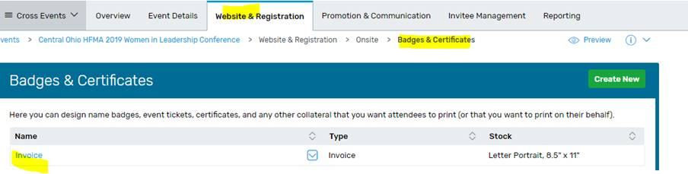

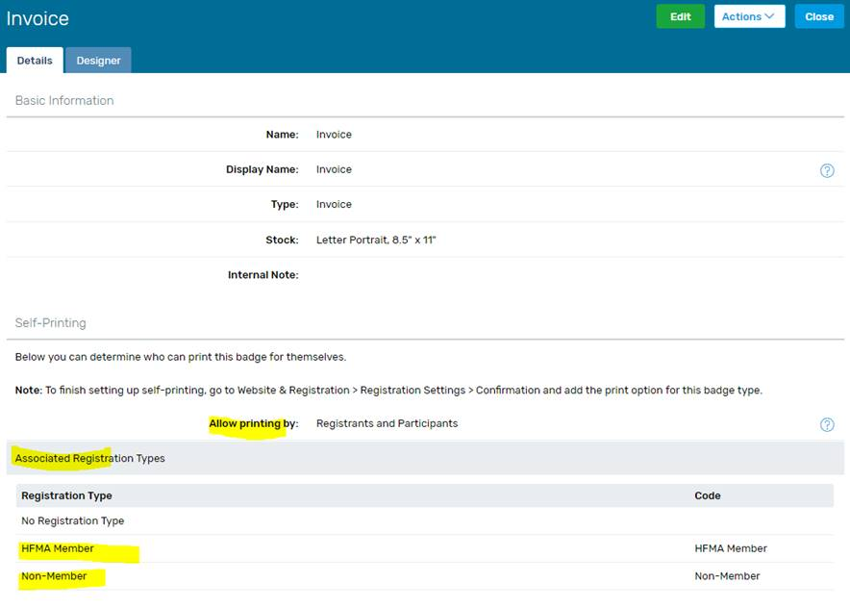
Here is how you can find the data tag for the invoice link to be added on your confirmation email

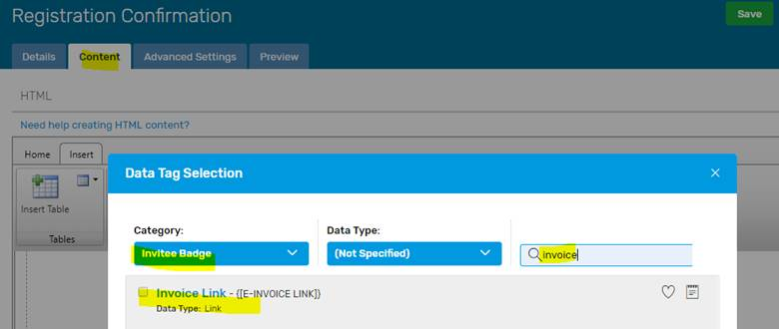
Here is how it will look on your confirmation email:

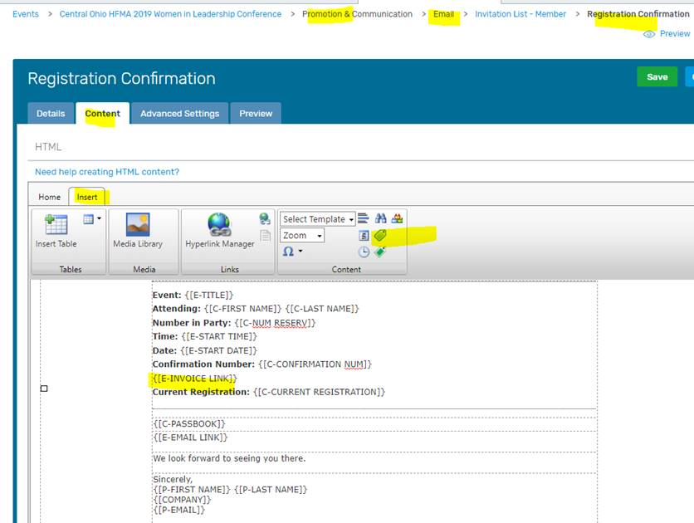
If you are not receiving Ada’s Cvent tips email chapter@hfma.org and ask to be put on the list.

