For the 2022 tax year, the IRS will continue to use the relatively new information return – Form 1099-NEC – and enforce its filing requirement.

What’s Form 1099-NEC?
Chapters are required to file Internal Revenue Service (IRS) Form 1099-NEC to report payments ($600 or more) to non-employees. Previously, this was reported on box no 7 of Form 1099-MISC. Now, the IRS has separated the reporting for non-employee compensation by reintroducing Form 1099-NEC from the 2020 tax year.

for each person or non-corporate entity to report any nonemployee compensation of $600 or more for calendar year 2022.

Nonemployee compensation includes fees, commissions, prizes, awards, and any other forms of compensation for services performed by someone who isn’t classified as an employee.
Common examples of nonemployees are independent contractors or attorneys you pay for legal services.
Generally, you’re required to file a Form 1099-NEC if you meet the following conditions:
- You paid someone who’s not your employee
- You paid for services in the course of your trade or business
- You paid an individual or partnership
- You paid at least $600 to the payee during the year

The most common payment chapters make that would require filing Form 1099-NEC:
- SPEAKER FEE (services)
  - However, if a speaker is reimbursed for actual expenses, documented by receipts, those expenses need not be reported on the Form 1099-NEC.

How to Fill out Form 1099-NEC
Form W-9, Request for Taxpayer Identification Number and Certification is a one-page IRS information form that individuals and businesses use to send their taxpayer identification number to other individuals, clients, banks and other financial institutions.
You must obtain a Form W-9 from for any party the chapter is doing business with to help identify the type of business and whether a Form1099-NEC is required.
The Form W-9 will help complete Form 1099-NEC as it verifies:
- NAME OF THE PERSON AND OR BUSINESS
- SOCIAL SECURITY NUMBER OR TAX ID NUMBER
- ADDRESS
- TYPE OF BUSINESS (C-Corp, S-Corp, Partnership, etc.)
* Form 1099-NEC does not need to be provided to parties that select LLC and check S corporation or C corporation
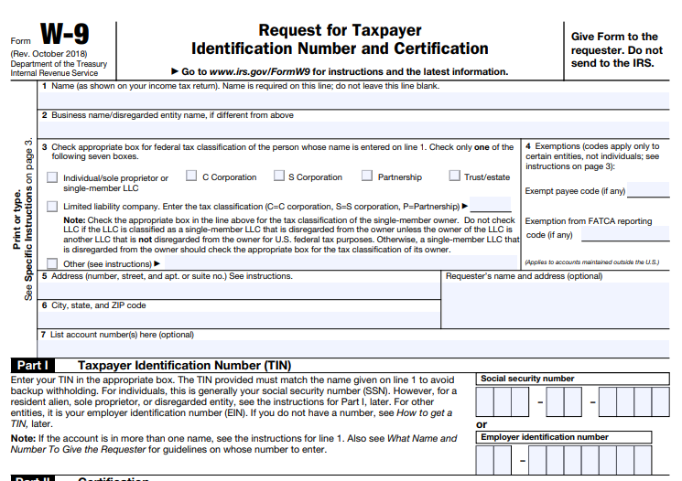

Where to Get Form 1099-NEC
You can get 1099-NEC forms at your local office supply stores, directly from the IRS https://www.irs.gov/forms-pubs/order-products , or using business tax software programs. You cannot use a form that you download from the internet for Form 1099-NEC because the red ink on Copy A is special and can’t be copied.
You must use the official form.
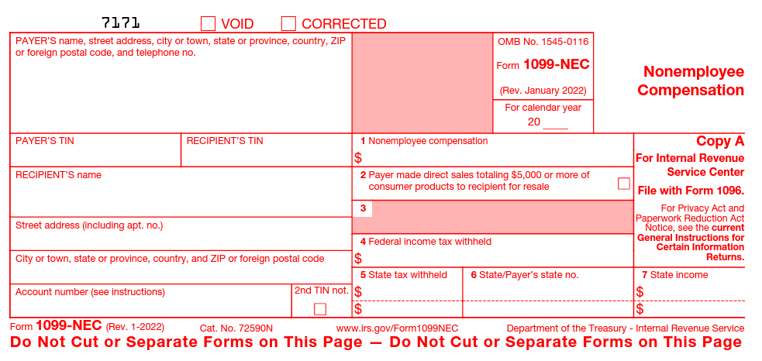

Where do you send Form 1099-NEC?

There are multiple copies of Form 1099-NEC you must distribute. A completed Form 1096 must also be filed to the IRS.

Copy A and Form 1096 (summary and transmittal form) are to be sent/transmitted to the IRS

Copy 1: State tax department, if applicable

Copy B: Independent contractor

Copy 2: Independent contractor

Copy C: Keep for business records

How to fill out Form 1096:

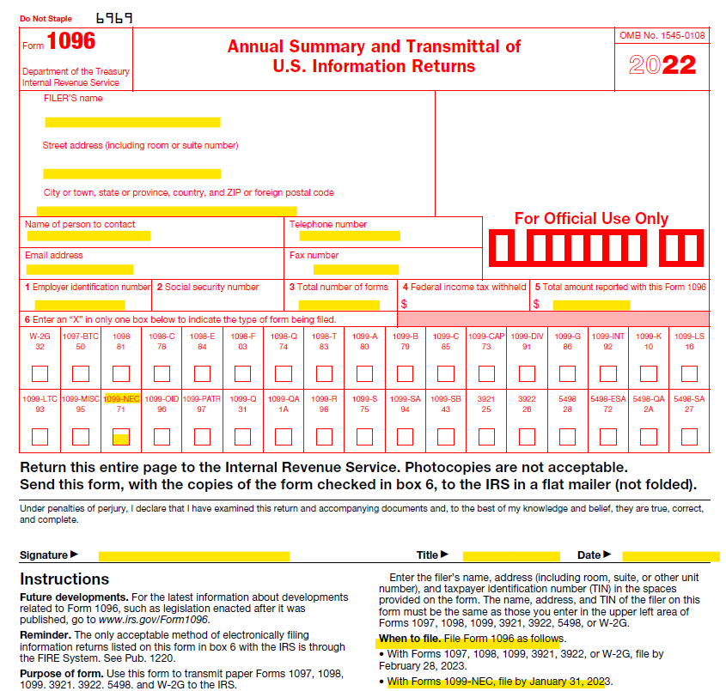

The first part, including boxes 1-5 asks you for basic information. Name, address, contact information, employer identification number or social security number, the total number of 1096 forms you are submitting to the IRS the calendar year and enter an X in the box for the type of form that is being submitted.

Remember that the information you’re entering here applies to the chapter, not the independent contractor you’re submitting a Form 1099-NEC for.

Feel free to use/list HFMA’s address on all forms completed in case there are future inquiries: 2001 Butterfield Rd., Ste 1500, Downers Grove, IL 60515

When are 1099 forms due?
For the 2022 tax year, Form 1099-NEC is due to both the IRS and recipients on Jan. 31, 2023.
There are no filing extensions for either form.

1099-NEC form state requirements
Filing requirements for some states might differ from federal requirements. We recommend researching reporting requirements based on the state of the 1099 recipient.
For most, if there is State Withholding, you’re required to file a 1099-NEC form with that state but, we still recommend verifying your responsibilities by checking the recipient’s state website.

Additional Resources:
https://www.irs.gov/forms-pubs/about-form-1099-nec
https://www.irs.gov/pub/irs-pdf/f1099nec.pdf
https://www.irs.gov/forms-pubs/order-products
https://support.waveapps.com/hc/en-us/articles/360038436771-Form-1099-NEC-State-filing-requirements

