For the 2023 tax year, the IRS will continue to use the relatively new information return – Form 1099-NEC – and enforce its filing requirement.

What’s Form 1099-NEC?
Chapters are required to file Internal Revenue Service (IRS) Form 1099-NEC for each person or non-corporate entity to report any nonemployee compensation of $600 or more for calendar year 2023.
Nonemployee compensation includes fees, commissions, prizes, awards, and any other forms of compensation for services performed by someone who isn’t classified as your employee.
Common examples of nonemployees are independent contractors or attorneys you pay for legal services.
Generally, you’re required to file a Form 1099-NEC if you meet the following conditions:
- You made the payment to someone who is not your employee.
- You made the payment for services in the course of your trade or business (including government agencies and nonprofit organizations).
- You made the payment to an individual, partnership, estate, or, in some cases, a corporation.
- You made payments to the payee of at least $600 during the year.

Examples related to our organization:
- The most common payments chapters make that would require filing form 1099-NEC are fees and expenses paid to speakers at chapter programs.

- A fee paid to a nonemployee, including an independent contractor, or travel reimbursement for which the nonemployee did not account to the payer, if the fee and reimbursement total at least $600.

- Payments to nonemployee entertainers for services.

How to Fill out Form 1099-NEC
Form W-9, Request for Taxpayer Identification Number and Certification is a one-page IRS information form that individuals and businesses use to send their taxpayer identification number to other individuals, clients, banks and other financial institutions.
You must obtain a form W-9 from any party the chapter is doing business with to help identify the type of business and whether a form1099-NEC is required.
The W9 will help complete Form 1099-NEC as it verifies the TAXPAYER ID or SSN number, the name of the business or person, and address. Most importantly, it serves as audit support.

You’ll be able to gather the:
- NAME OF THE PERSON AND OR BUSINESS
- SOCIAL SECURITY NUMBER OR TAX ID NUMBER
- ADDRESS
- TYPE OF BUSINESS TYPE (C-Corp, S-Corp, Partnership, etc.)
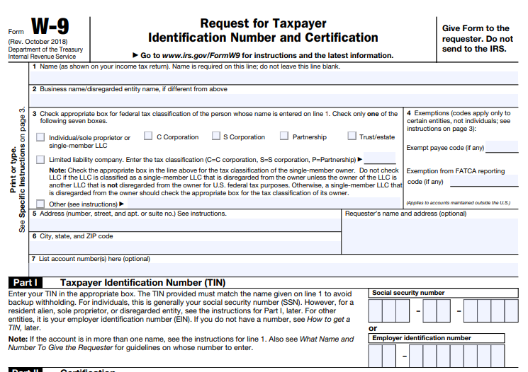

Where to Get Form 1099-NEC
You can get 1099-NEC forms at your local office supply stores, directly from the IRS https://www.irs.gov/forms-pubs/order-products , or using business tax software programs. You cannot use a form that you download from the internet for Form 1099-NEC because the red ink on Copy A is special and can’t be copied.
You must use the official form.
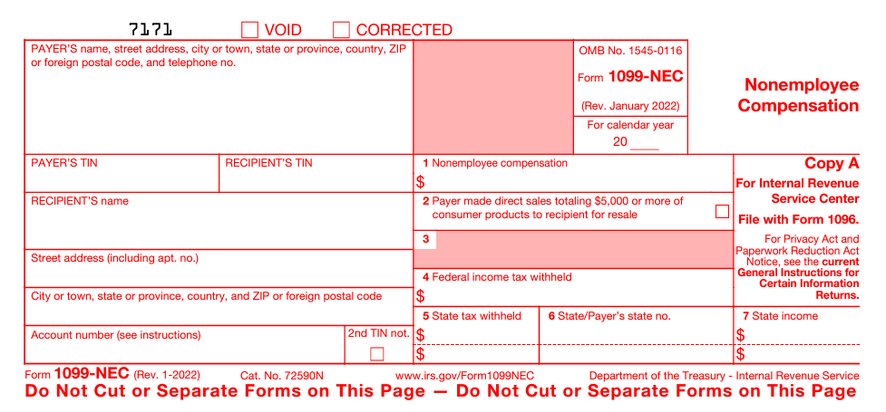

How to complete Form 1099-NEC?
Business information – Your Federal Employer ID Number (EIN), your business name and your business address.
Recipient's ID Number – The recipient's Social Security number or Federal Employer ID Number (EIN).

Payment Amounts – Enter nonemployee compensation amounts paid in Box 1.

Where do you send Form 1099-NEC?

There are multiple copies of Form 1099-NEC you must distribute. A completed Form 1096 must also be filed to the IRS.

Copy A and Form 1096 (summary and transmittal form) are to be sent/transmitted to the IRS

Copy 1: State tax department, if applicable

Copy B: Independent contractor

Copy 2: Independent contractor

Copy C: Keep for business records

How to fill out Form 1096:

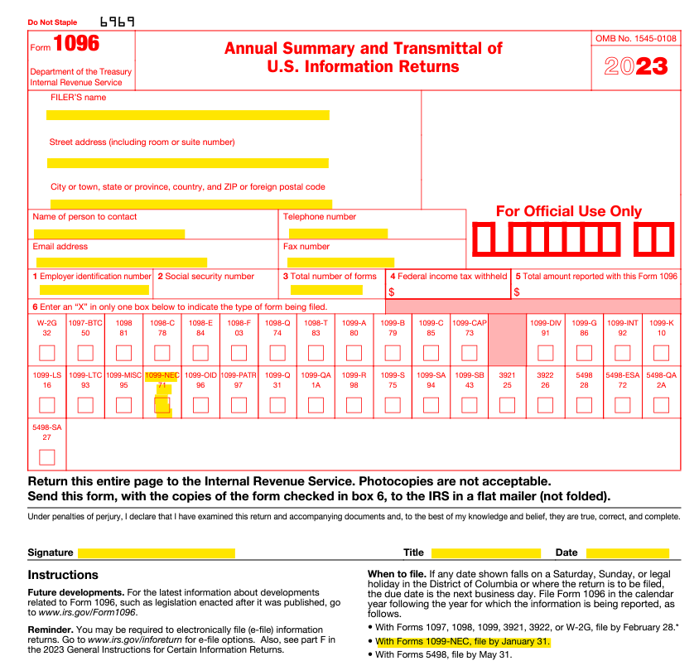

The first part, including boxes 1-5 asks you for basic information. Name, address, contact information, employer identification number, and the total number of 1096 forms you are submitting to the IRS this year.

Remember that the information you’re entering here applies to the chapter, not the independent contractor you’re submitting a 1099-NEC for.

Feel free to use/list HFMA’s address on all forms completed in case there are future inquiries: 2001 Butterfield Rd., Ste.1500, Downers Grove, IL 60515

When are 1099 forms due?
For the 2023 tax year, Form 1099-NEC is due to both the IRS and recipients on Jan. 31, 2024.
There are no filing extensions for either form.

Additional Resources:
https://www.irs.gov/instructions/i1099mec
https://www.irs.gov/forms-pubs/about-form-1099-nec
https://www.irs.gov/pub/irs-pdf/f1099nec.pdf
https://www.irs.gov/forms-pubs/order-products

